COUNCIL ASSESSMENT REPORT
Panel Reference | PPSNTH-6
DA Number | DA-112-2019
LGA | Armidale Regional
Proposed Development | 29.9MW Solar Farm and Associated Infrastructure
Street Address | 597 Gara Road and 1060 Grafton Road METZ NSW 2350
Applicant/Owner | Applicant: Stringybark Solar Farm Pty Ltd -  Owners: Mr L & Mrs T Fittler and Mrs S Quaife
Date of DA lodgement | 19 August 2019
Number of Submissions | 147 submissions received
Recommendation | Approval with Conditions
Regional Development Criteria (Schedule 7 of the SEPP (State and Regional Development) 2011 | Clause 5 – Private infrastructure and community facilities over $5 million  - Electricity generating works
List of all relevant s4.15(1)(a) matters | - SEPP No 44 – Koala Habitat Protection;  - SEPP No 55 – Remediation of Land;  - SEPP (Infrastructure) 2007;  - SEPP (Primary Production and Rural Development) 2019;  - SEPP (State and Regional Development) 2011;  - Armidale Dumaresq Local Environmental Plan 2012;  - Armidale Dumaresq Development Control Plan 2012;  - The Application has been publicly notified and advertised for 28 days;
List all documents submitted with this report for the Panel’s consideration | - Statement of Environmental Effects prepared by Eco Logical Australia, dated August 2019 and associated appendices as referenced on page 14 of this Report.
Report prepared by | John Goodall
Report date | 27 November 2019

Summary of s4.15 matters  Have all recommendations in relation to relevant s4.15 matters been summarised in the Executive Summary of the assessment report? | Yes
Legislative clauses requiring consent authority satisfaction  Have relevant clauses in all applicable environmental planning instruments where the consent authority must be satisfied about a particular matter been listed, and relevant recommendations summarized, in the Executive Summary of the assessment report?  e.g. Clause 7 of SEPP 55 - Remediation of Land, Clause 4.6(4) of the relevant LEP | Yes
Clause 4.6 Exceptions to development standards  If a written request for a contravention to a development standard (clause 4.6 of the LEP) has been received, has it been attached to the assessment report? | No
Special Infrastructure Contributions  Does the DA require Special Infrastructure Contributions conditions (S7.24)?  Note: Certain DAs in the Western Sydney Growth Areas Special Contributions Area may require specific Special Infrastructure Contributions (SIC) conditions | Not Applicable
Conditions  Have draft conditions been provided to the applicant for comment?  Note: in order to reduce delays in determinations, the Panel prefer that draft conditions, notwithstanding Council’s recommendation, be provided to the applicant to enable any comments to be considered as part of the assessment report | No
Further Application Details:
DA Lodgement Date: | 19 August 2019
Additional Information received? / date? | 28, 30 & 31 October 2019
Estimated Construction Value of Development: | $32,120,000.00
Capital Investment Value: | $29,200,000.00

Glossary of terms used in this report:
ACHA – Aboriginal Cultural Heritage Assessment
ADLEP – Armidale Dumaresq Local Environmental Plan 2012, as amended
AHIMS – Aboriginal Heritage Information Management System
BAM – Biodiversity Assessment Method
BC Act – Biodiversity Conservation Act 2016
BCA – Building Code of Australia
BDAR- Biodiversity Development Assessment Report
BOS- Biodiversity Offset Scheme
BSAL – Biophysical Strategic Agricultural Land
CIV – Capital Investment Value
DA – Development Application
DCP - Armidale Dumaresq Development Control Plan 2012, as amended
DPIE – Department of Planning, Industry and Environment
EEC – Endangered Ecological Community
EP&A Act – Environmental Planning and Assessment Act 1979
MW - Megawatt
NRPP – Northern Regional Planning Panel
NSR – Noise sensitive receiver
PV – Photovoltaic
RMS – Roads and Maritime Services
RSD – Regionally Significant Development
SEE – Statement of Environmental Effects
SEPP – State Environmental Planning Policy

Assessment Report and Recommendations – Table of Contents
 | Page No.
Executive Summary (including recommendations) |  | 1
Subject Site and Locality |  | 3
Proposed Development |  | 10
Submitted documents and plans |  | 14
Referrals undertaken and other approvals required, Political Donations |  | 15

Assessment under Environmental Planning and Assessment Act 1979 - Matters for Consideration :
s. 4.15(1)(a) the provisions of the following that apply to the land to which the development application relates:
- any environmental planning instrument [relevant SEPPs and Council’s LEP] |  | 17
(ii) any draft environmental planning instrument |  | 26
(iii) any development control plan [Council’s DCP 2007] |  | 26
(iiia) any planning agreement that has been entered into under section 7.4, or any draft planning agreement that a developer has offered to enter into under section 7.4 |  | 33
(iv) the regulations |  | 33
4.15 (b) the likely impacts of the development, including environmental impacts on both the natural and built environments, and social and economic impacts in the locality |  | 33
4.15 (c) the suitability of the site for the development |  | 56
4.15 (d) any submissions made in accordance with the Act or the Regulations |  | 57
4.15 (e) the public interest |  | 87
Assessment Conclusion - Key Issues |  | 89
Recommendation |  | 90
Appendix 1 - Proposed conditions of consent |  | Sep. doc’t
Submissions received |  | Sep. doc’t

Assessment Report and Recommendations

DA-112-2019 / JRPP Ref PPSNTH-6

Executive Summary
Consideration by Northern Regional Planning Panel:
The Northern Region Planning Panel is the determining authority for this DA pursuant to Clause 5(a), Schedule 7 of State Environmental Planning Policy (State and Regional Development) 2011, as the proposed development is for private infrastructure works, being electricity generating works, with a capital investment value (CIV) of more than $5 Million and as such is considered to be ‘Regionally Significant Development’ (RSD). The capital investment value of the project, as estimated by the Applicant, is $29.2 Million (excl. GST).
Proposal:
The proposed development is for the construction and operation of a utility-scale photovoltaic (PV) solar farm with associated infrastructure, with a nameplate capacity of no more than 29.9 megawatts (MW), located approximately 14km east of Armidale NSW. Once fully operational the facility will have the capacity to produce enough energy to power the equivalent of 15,000 average NSW households each year.
Permissibility:
The subject lots being Lot 3 DP 1206469, known as 597 Gara Road and Lot 3 DP 786950 & Lot 13 DP 822753 and known as 1060 Grafton Road, are currently zoned RU1 Primary Production under ADLEP 2012.
The proposed development is considered to be electricity generating works which is defined under the Standard Instrument as:
- a building or place used for the purpose of making or generating electricity.
The proposed development within a prescribed rural zone is permitted with consent under Clause 34(b) of State Environmental Planning Policy (Infrastructure) 2007.
Key Issues :
From the attached Assessment Report, key issues for this project can be summarised as follows:
- The Natural Resources Access Regulator (NRAR) has advised that a controlled activity approval is not required for this proposal.
- Roads and Maritime Services have assessed the proposed development and provided their assessment of potential road impacts and recommendations regarding upgrades.
- The subject site has been assessed in accordance with SEPP No 44 - Koala Habitat Protection and found not to contain potential Koala habitat.
- The subject site has been assessed in accordance with Clause 7 of SEPP No 55 – Remediation of Land and is considered to be suitable for the proposed development.
- The proposed development has been assessed in accordance with SEPP (Infrastructure) 2007 and is considered to be permissible under Clause 34(1)(b) and also Clause 34(7) of the SEPP.
- The proposed development has been assessed in accordance with Clause 101 of SEPP (Infrastructure) 2007 and is considered to be satisfactory subject to conditions.
- The proposal has been assessed in accordance with SEPP (Primary Production and Rural Development) 2019 and is considered satisfactory have regard to the SEPP.
- The proposal is Regionally Significant Development under Clause 5(a) of Schedule 7 of SEPP (State and Regional Development) 2011.
- The proposal is considered to be consistent with the provisions of Armidale Dumaresq Local Environmental Plan 2012.
- No draft environmental planning instrument applies to this proposal.
- The proposal has been assessed under the relevant Chapters of Armidale Dumaresq Development Control Plan 2012 and is considered to be satisfactory have regard to the relevant provisions subject to conditions.
- There are no planning agreements for this proposal.
- Relevant Clauses of the Regulations have been considered during the assessment of this proposal.
- The likely impacts of the development, including environmental impacts on both the natural and built environments, and social and economic impacts in the locality have been assessed during the assessment of this proposal and are considered to be satisfactory in the circumstances of the case subject to recommended conditions as detailed throughout this report.
- The site has been assessed for its suitability for the proposed development and is considered to be suitable, subject to conditions.
- The Application was notified for 28 days to property owners within a 2km radius of the subject site and was also advertised in the local newspaper from 21 August 2019 until 18 September 2019. At the conclusion of the notification period 147 submissions were received by Council. The matters raised in these submissions have been considered in accordance with s4.15(1)(d) of the Act and are detailed below in the Report together with responses from the Applicant and Council’s assessment.
- Having regard to the matters considered throughout this report and the assessment of the Application against the relevant heads of consideration under S4.15(1) of the Act, the proposal is not detrimental to the public interest.
As a result of this assessment, the proposed development is recommended for conditional consent. Appendix 1 to this report contains all relevant conditions identified throughout the assessment process and as discussed in the Council officer’s report.
Recommendations
(a) That having regard to the assessment of the Application, DA-112-2019 (JRPP ref PPSNTH-6) be granted conditional consent in the terms set out in Appendix 1 to this report.
(b) That those persons that made submissions in relation to the Application be notified of the determination in writing.

Subject Site and Locality
The proposed development know as Stringybark Solar Farm is to be located principally on Lot 3 DP 1206469, known as 597 Gara Road, and on where the Development Envelope for the solar arrays and cabling will be located. The proposed substation, cabling and access track will be located on Lot 3 DP 786950 and Lot 13 DP 822753, known as 1060 Grafton Road Metz which is located adjacent and to the west of the subject site.
The subject site is located in a rural area of the LGA approximately 14km to the east of the city of Armidale. The site is accessed via Grafton Road (Waterfall Way) and Gara Road.
The Development Envelope located on Lot 3 DP 1206469, 597 Gara Road, forms part of a greater landholding of approximately 152 ha that has been largely cleared of native vegetation and sown to improve pastures for grazing of livestock. Patches of retained/regenerated woodland lie along the ridge tops outside the Development Envelope and which forms the northern boundary of the landholding. The Development Envelope slopes in a southerly direction towards Gara Road, which lies along the southern extent of the landholding.
The Development Envelope is currently used as agricultural land but it has not been mapped as Biophysical Strategic Agricultural Land. The entire Development Envelope has been previously cleared for grazing and sown to improved pasture. There are no remaining paddock trees located within the Development Envelope.
An existing residence is located to the north outside the Array Area alongside a cluster of mature trees.
Following an assessment of the site and for the purposes of the BAM, the proposal has been intentionally located in the most disturbed southern section of the landholding, adjacent to Gara Road, where almost all native vegetation has been removed, so as not to impact on the higher quality vegetated areas of the landholding.
The land area associated with the Proposal consists of approximately 91ha for the Development Envelope in conjunction with an additional 2.3ha for the new substation, new access and underground cabling within a 2m wide easement.
The substation will be located adjacent to an existing essential Energy 66kV distribution line, 1.5km to the north-west of the Development Envelope. The location of the substation has been selected to minimise potential visual impacts as well as minimising impacts on biodiversity and bush fire prone land.
The subject site is currently zoned RU1 Primary Production and is currently used for extensive agricultural/grazing purposes. Land immediately surrounding the subject site, is currently also largely used for similar purposes, in conjunction with associated residences. The new Armidale landfill site is located immediately to the north of the subject site.
Three existing residences that are not involved with the development are located within 1km of the site. The closest non involved residence is located approximately 368m from the eastern boundary of the site and the closest RU4 Primary Production Small Lots zoned land is located approximately 700m to the south west of the site.

Subject Site Selection Criteria
The proponent has advised that a multi-criteria site selection process was undertaken to identify the most suitable location for the proposal, which included consultation with network operators. The capacity to export electricity from a development site to the National Energy market was a key factor in selecting a suitable site for large scale generation in NSW.
The following site selection criteria were considered in the identification of suitable development sites for the Proposal:
• Solar radiation;
• Access to the existing road network;
• Access to the electricity grid;
• Capacity of the local transmission/distribution lines;
• Topography and key landscape features;
• Minimal environmental constraints / impact;
• Existing land uses;
• Access to suppliers and materials;
• Proximity to residential settlement; and
• Landowner support.

With this in mind, the proponent reviewed sites across the local area and elsewhere in NSW and determined that the subject site represented the most favourable location, taking the above matters into consideration. Initially the proposal was envisaged to be for a much larger development which also incorporated the adjacent landholding at Lot 3 DP 786950 and Lot 13 DP 822753.

Following more detailed environmental studies it was identified that the location was not suitable for a large scale development, due to the site design principles that seek to avoid and/or minimise impacts where possible. Initial topographic, visual and ecological assessments indicated that the area was better suited to smaller scale developments.

The Development Envelope is located on undulating landscape with elevations ranging from 940-980m AHD. The substation is located at an elevation of between 980-990m AHD.

The site has been historically cleared and cultivated for improved pastures and for the purposes of sheep and cattle grazing. Surrounding land uses include:
- Agriculture
- Transportation – Waterfall Way is a major road connecting Armidale to the coast;
- Rural residential – There are two non-involved residences within 1 km of the Proposal; and
- Armidale Regional Council has identified and developed the new Armidale Regional Landfill on the adjoining block immediately to the north of the Development Envelope (Lot 1 DP 1206469).

The proposal will involve the use of approximately 94ha of the total combined land holding across the two properties of approximately 665ha, for the lifespan of the proposal, which is estimated to be around 30 years. Given the relatively small footprint on the agricultural holding and the relatively temporary nature of the proposal it is not anticipated that it would significantly impact on agricultural production at a regional and state level.

The subject site is not identified as containing any Biophysical Strategic Agricultural Land nor is it identified on Council’s GIS as being classified as significant agricultural land. The land/soil capability of the site has been identified as being low to moderate classification, based on the biophysical features of the soils and landscape. The site is almost entirely occupied by native/exotic grasslands, with the panel arrays being located exclusively on poor condition grasslands dominated by exotic species with little biodiversity value.

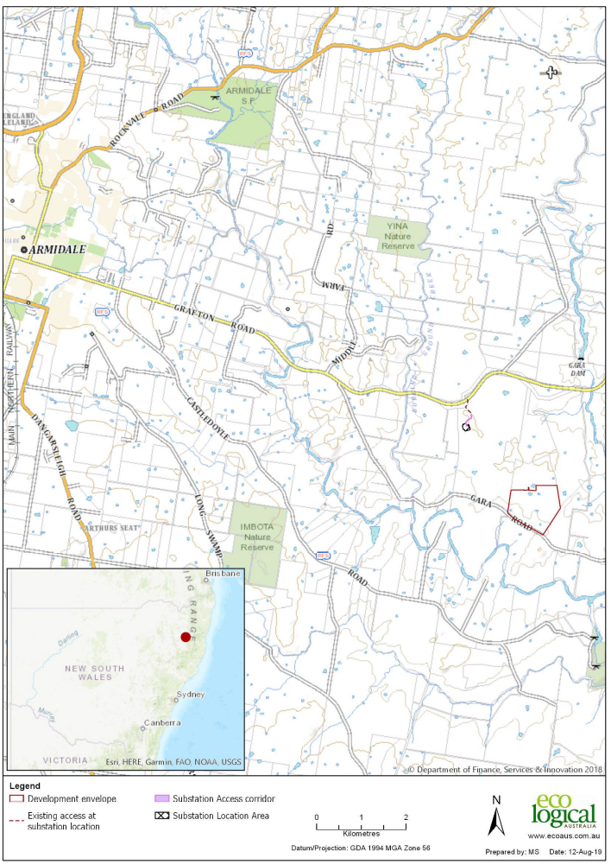

Figure 1 – Location of subject site in context with surrounding area

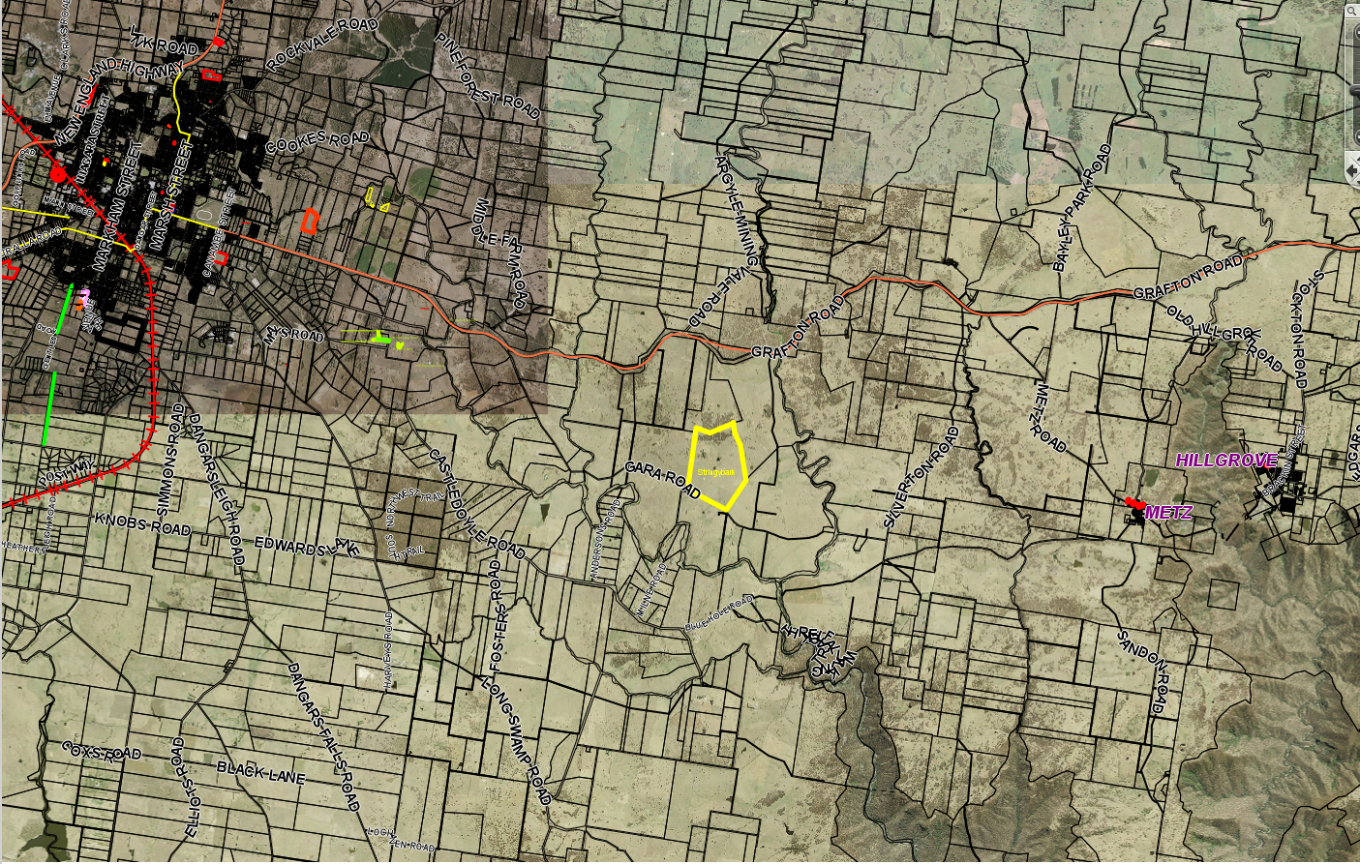

Figure 2 – Locality Plan

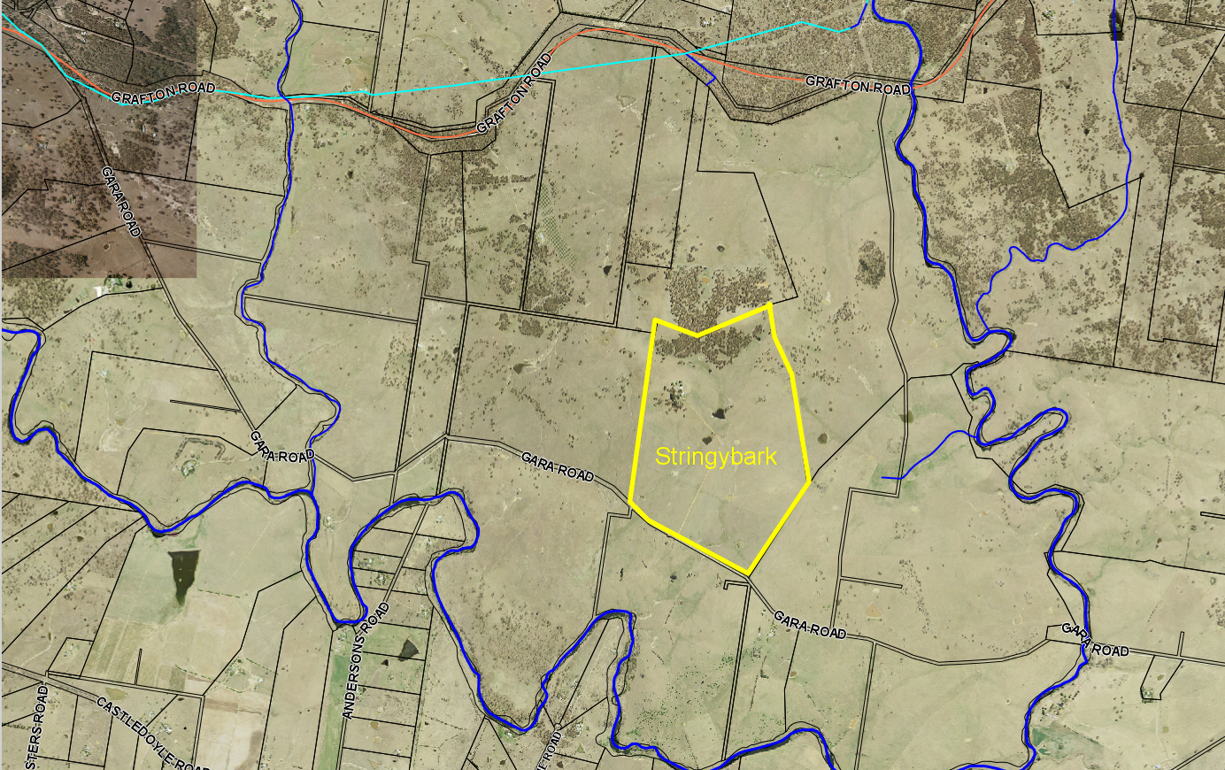

Figure 3 – Site Plan

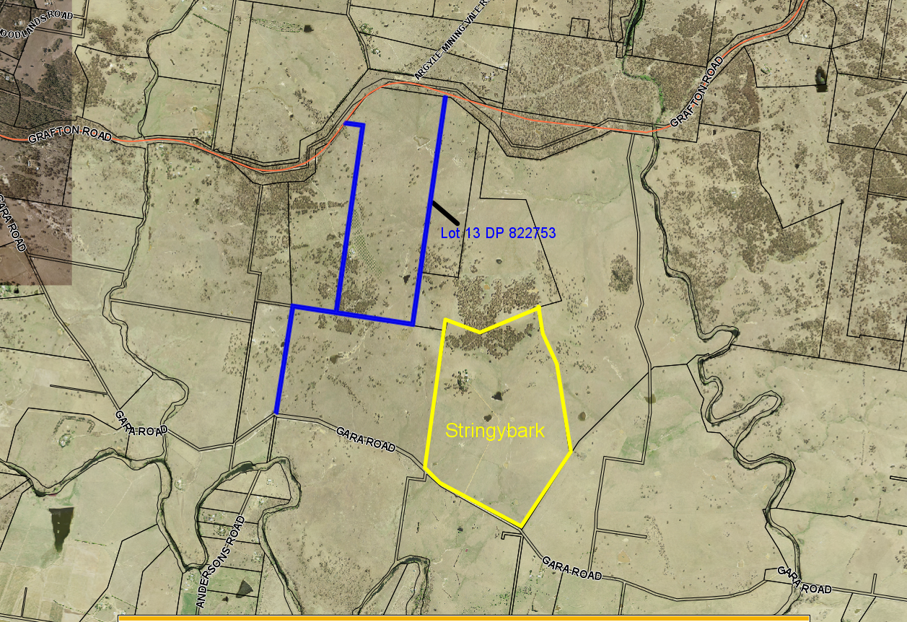
Figure 4 – Proposed site also showing location of Lot 13 DP 822753
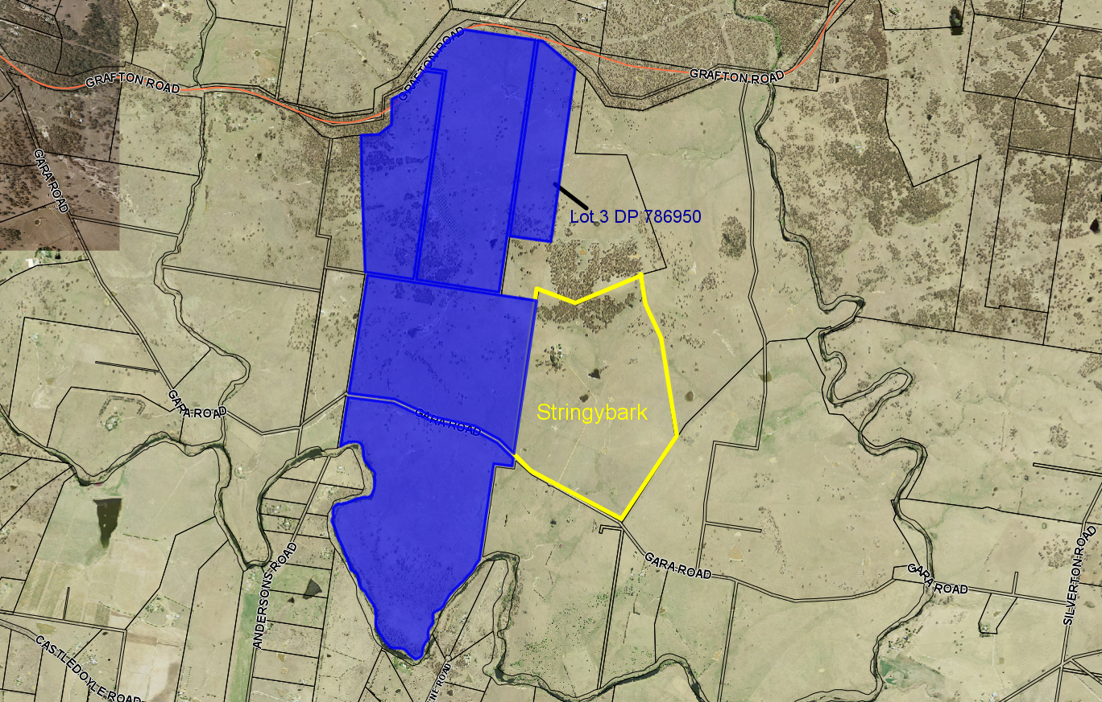
Figure 5 – Proposed site also showing location of adjoining Lot 3 DP 786950
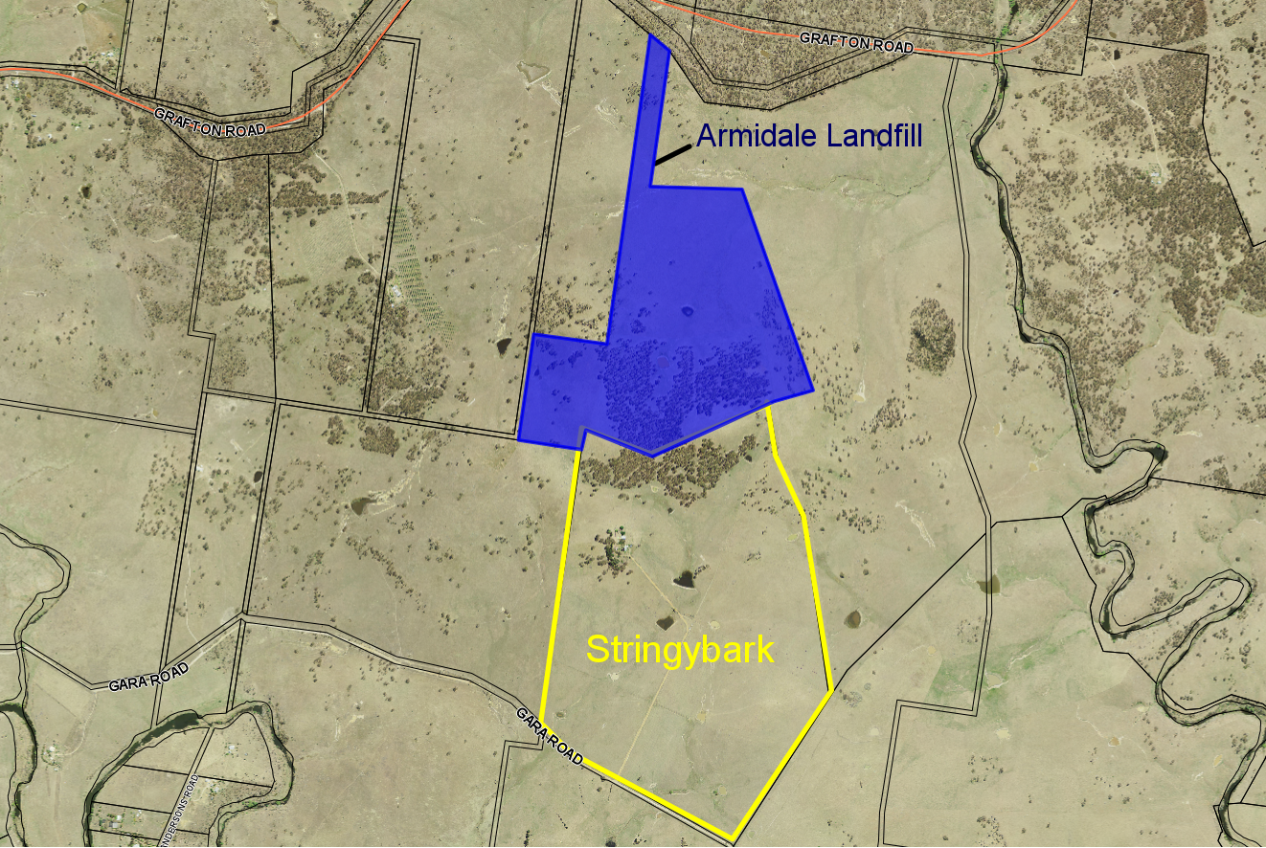
Figure 6 – Proposed site showing proximity to Armidale landfill site

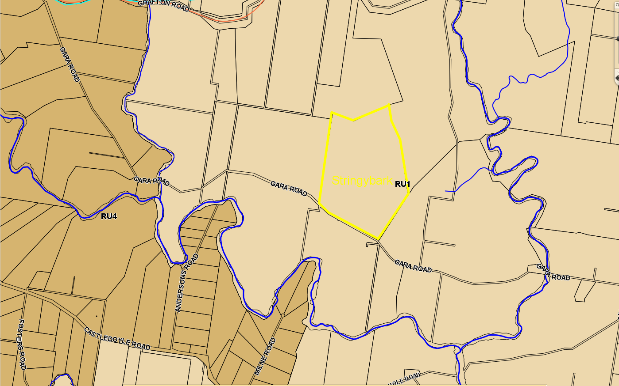

Figure 7 – Extract from land zoning map

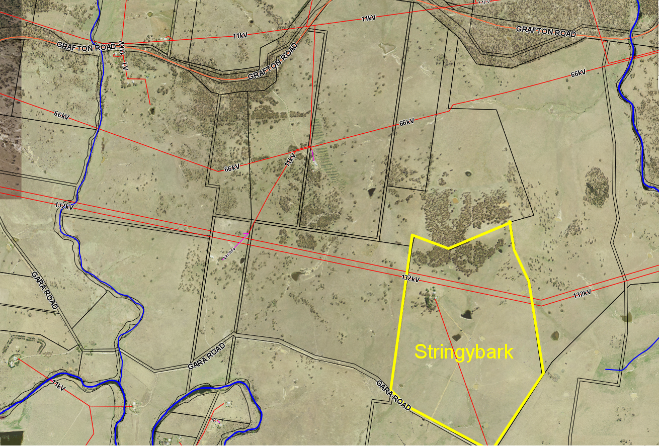

Figure 8 – Location of Electricity lines in relation to the development site

Proposed development
The proposed development is for the construction and operation of a utility-scale photovoltaic (PV) solar farm and associated infrastructure, with a capacity of no more than 29.9 megawatts (MW) located approximately 14km east of Armidale NSW. Once fully operational the facility will have the capacity to generate approximately 64 GWh of clean electricity annually over a 30 year lifespan, which is enough energy to power the equivalent of 15,000 average NSW households each year.
Additionally, the electricity generated by the proposal would result in significant carbon savings. Based on current NSW emission figures it is estimated that approximately 53,000 tonnes of CO₂ would be displaced by the proposal annually.
The proposal will generate electricity through the conversion of solar radiation to electricity using PV panels, laid out across the proposed site in a series of modules, mounted on a single axis tracking system with piled supports.
Key components of the proposal include:
- PV panels to be located within the Array Area mounted on a single axis tracking system with a maximum height of 4m above natural ground level at maximum tilt;
- Approximately 12 inverters (up to 3m high) located within the Array Area at least 50m from any external boundary;
- On or below ground cabling connecting the PV panels to and between inverters;
- Operations compound (area 60m x 60m), including buildings with a maximum height of 5m and car parking for up to eight (8) vehicles;
- A fire track 4m wide, located within a 10m defendable fire break area around the perimeter of the development Envelope;
- A dedicated water tank for firefighting (4m high);
- A perimeter security fence up to 2.5m high;
- Four (4) gated emergency access points along the perimeter fence, the main Gara Road access and a new landholder access to the existing farmhouse and land at the rear of the landholding;
- Three (3) vegetation landscape screens, one 12m wide and two 5m wide (maintained to be at least 4m high). The screens will be located across the southern and western perimeters of the Development Envelope to help screen the proposal from nearby residences and local road users along Gara Road; and
- Internal access tracks within the Array Area (4m wide).
It is estimated that there will be approximately 115,000 individual PV panels, with typical dimensions of approximately 2m x 1m. The panels will be fitted to a single axis tracking system that will allow the PV panels to track the sun as it moves from east to west throughout the day.
The Tracking system will be installed in rows orientated in a north south direction. The minimum spacing between each of the rows will be 5.5m allow enough area for vehicles to access for maintenance purposes. The tracking system will be supported by piles either mechanically driven or screwed into the ground.
The proposal will connect to the national electricity grid via a new substation located on Lot 3 DP 786950, approximately 1.5km to the north of the Array Area, adjacent to an existing Essential Energy 66 kilovolt (kV) distribution line. An underground cable located within a 2m wide easement, will connect the Proposal to the proposed Substation.
Substation:
- Substation up to 8 m high connecting the Proposal to the national electricity grid (area 45 m x 100 m);
- A perimeter security fence up to 2.5 m high enclosing the Substation;
- A 10 m defendable firebreak area around the perimeter of the Substation;
- A dedicated water tank for firefighting (4 m high);
- Access from Waterfall Way and one (1) emergency access point at the Substation; and
- Vegetation landscape screen at the substation, 10 m wide (maintained to be at least 4 m high).
Operations compound:
An operations compound will be located adjacent to the southern entrance to the site of the Development Envelope, within an area of approximately 60m x 60m, shown highlighted in blue hatching in figures 8 & 9 below, to accommodate the maximum number of staff required during the operational phase of the development (3-6 staff). The compound would include:
- An office and maintenance building, consisting of an office, toilets, showers, staff room and kitchen;
- A storage building/shed;
- A chemical storage shed;
- Parking;
- Water storage;
- Water tank dedicated for fire protection purposes;
- A septic tank; and
- A workshop.
In addition, there will also be a temporary construction compound required to facilitate the construction and decommissioning phases of the Proposal. The temporary compound area is shown below in Figures 9 & 10.
The construction compound would include:
- Temporary construction offices (up to 5 m high);
- Car and bus parking areas;
- Staff amenity block including portable toilets, showers and a kitchen, designed for peak staff numbers during the construction period; and
- Laydown areas.
Once operational, the construction compound will be decommissioned.
It is noted that the proponent has advised that the example array layout and design shown below in Figure 10 is only indicative at this time and that the final design and layout will be determined post consent. The proponent has further advised that this is largely due to the fast moving and dynamic nature of the PV market and that this will ensure that the most suitable and latest technology can be utilised at the site to maximise the benefits. The final design however will not exceed the environmental or technical parameters as proposed and assessed within the submitted application and supporting documentation, which will be the maximum area of the development itself within which all components of the array area will be accommodated.
Finally, the scale of the proposal will also be subject to more detailed discussions post determination with Essential Energy, who at this stage have only provided an estimate of the capacity of the existing distribution line, but it has been advised that the capacity of the solar farm will not exceed 29.9MW.

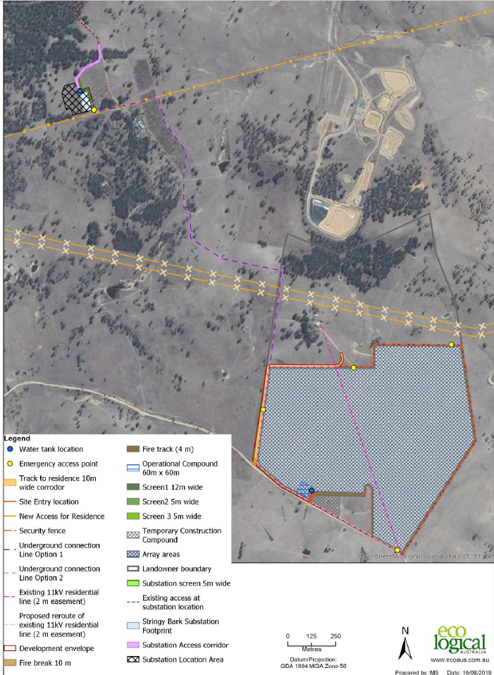

Figure 9 – Proposed site indicating development envelope and substation location

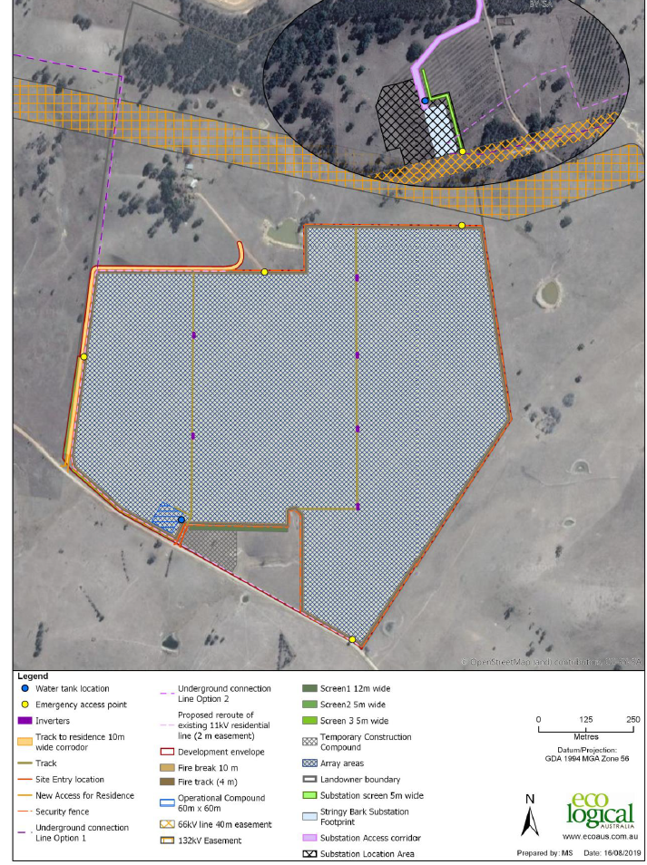

Figure 10 – Example of array layout and design

Submitted Documents and Plans
Project documentation has been coordinated on behalf of the Applicant by Eco Logical Australia and a range of other specialist consultants. Specific documents and plans relied upon for this assessment, are as follows:
- Statement of Environmental Effects Project Number 19ARM-13082, Version V3, dated August 2019 by Eco Logical Australia, including the following appendices:
- Biodiversity Development Assessment report (BDAR) – Eco Logical Australia, Project Number 19NEW12328, Version V1, dated 15 August 2019;
- Aboriginal Heritage Due Diligence Assessment – Eco Logical Australia, Project Number 19SYD-12937, Version V, dated 16 August 2019;
- Consultation Letter to neighbours, dated 10 May 2019;
- Consultation Slides – Stringy Bark Solar Farm;
- Landscape and Visual Impact Assessment - Jacobs Group (Australia) Pty Ltd, Final, dated 6 August 2019;
- Acoustic Assessment – TTM Consulting, Report Reference:19SYA0044 R01_3, dated 14 August 2019;
- Traffic and Transport Assessment (TTA) including Road Safety Audit –Constructive Solutions Pty Ltd, Project Number: 201948, Issue 2, Revision 1, dated 25 July 2019;
- BDAR Addendum for intersection upgrade – Eco Logical Australia, Project Number 19NEW-14586, Version v1c, dated 31 October 2019;
- Credit Summary Report, Intersection 1, dated 30 October 2019;
- Credit Summary Report, Intersection 2, dated 30 October 2019;
- Response to Public Submissions with Appendices
- Appendix A – Agronomy Report – GrazAg, dated 17 October 2019;
- Appendix B – Slope Suitability – Eco Logical Australia;
- Appendix C – Landscape and Visual Impact Response to Submissions – Jacobs Group (Australia), dated 14 October 2019;
- Appendix D – Traffic and Transport Assessment Response to Submissions – Constructive Solutions, dated 15 October 2019;
- Appendix E - Hydrology Assessment – Eco Logical Australia, Project Number 13082, Version 2, dated 31 October 2019;
- Appendix F – Bushfire Risk Analysis – Eco logical Australia, Project Number 19ARM_13082, Version 1, dated 30 October 2019.
Referrals undertaken and other approvals required
Referral Agency: | Response Date: | Summary of Advice / Issues:
Natural Resource Access Regulator (NRAR) |  | The following comments were received from NRAR in response to Council’s notification of the application:  The Natural Resources Access Regulator has reviewed documents for the above development application and considers that, for the purposes of the Water Management Act 2000 (WM Act), general terms of approval and / or a controlled activity approval is not required, and no further assessment by this agency is necessary.  Should the proposed development be varied in any way that results in development extending onto land that is waterfront land, or encompassing works that are defined as controlled activities, then the Natural Resources Access Regulator (NRAR) should be notified.
Roads and Maritime Services | 19/9/2019 | The following comments were received from RMS in response to Council’s notification of the application:  Roads and Maritime has reviewed the referred information and provides the following comments to assist the consent authority in making a determination;  - Consideration should be given to cumulative impacts that the traffic generation from Stringybark and Oxley Solar Farms will have on the Waterfall Way/Gara Road intersection and the local road network. This could require further improvements to the intersection and the local road if the projects occur at the same time.  - No concept designs were provided for the proposed road works on the Waterfall Way to demonstrate functionality and constructability.  - The minimum Austroads treatments for the intersection of the Waterfall Way and Gara Road to cater for turning traffic would be a BAL and BAR.  - The Traffic Assessment quotes the westbound left-turn movement as zero from the Waterfall Way into Gara Road this needs reconsidering. During construction there will be traffic moving between the array and sub-station sites in addition to any background traffic.  - The Waterfall Way access to the sub-station should at least be upgraded to a Rural Residential Access Standard and an Austroads BAR right-turn treatment to mitigate the reduced sight distance for approaching eastbound traffic. The access should be sealed for 30m to reduce tracking of material onto the Waterfall Way.
Referral Agency: | Response Date: | Summary of Advice / Issues:
Roads and Maritime Services – (cont) |  | - Any proposed roadworks on the Waterfall Way will require a Works Authorisation Deed (WAD) to be executed with Roads and Maritime Services. Roads and Maritime encourages the applicant to commence this process early to avoid any delays.  - Swept paths at identified intersections and accesses were not provided to demonstrate that the largest vehicle can be safely accommodated.  - No details of onsite parking and servicing arrangements were provided.  - Details of the minibus and parking arrangements in Armidale were not indicated.  - The proposed Traffic Management Plan (TMP) should be prepared by a suitably qualified person and include Traffic Control Plans (TCPs) designed in accordance with RTA’s Traffic Control at Worksites Manual. It should provide for construction, operational and decommissioning activities.  Should Council wish to condition the preparation of a Code of Conduct for haulage operators, this could include, but not be limited to;  a. A map of the primary haulage routes highlighting critical locations.  b. Safety initiatives for haulage through residential areas and/or school zones.  c. An induction process for vehicle operators & regular toolbox meetings.  d. A complaint resolution and disciplinary procedure.  e. Any community consultation measures for peak haulage periods.  All works on the classified (State) road will need to be designed and constructed in accordance with the current Austroads Guidelines, Australian Standards and Roads and Maritime Supplements.  The developer will be required to enter into a Works Authorisation Deed (WAD) with Roads and Maritime for any works deemed necessary on the classified (State) road. The developer will be responsible for all costs associated with the works and administration for the WAD.

This proposal will also require separate approvals under the Roads Act 1993, for any work in Council’s road reserves, connected with the proposal.

Political Donations
At the time of lodging the Development Application the Applicant indicated, pursuant to Section 10.4(4) of the Environmental Planning and Assessment Act 1979, that no reportable political donation or gift had been made by the Applicant or any person with a financial interest in this Application to a local Councillor or employee of Armidale Regional Council.

Assessment - Matters for Consideration
The assessment of this Development Application has been undertaken in accordance with Section 4.15 (1) of the Environmental Planning and Assessment Act 1979, as amended. In determining a development application, a consent authority is to take into consideration such of the following matters as are of relevance to the development application:
Section 4.15(1)(a) the provisions of the following that apply to the land to which the development application relates:

(i) the provisions of any environmental planning instrument
State Environmental Planning Policies (SEPPs):
The following SEPPs have been considered in connection with this development:
SEPP No 44 – Koala Habitat Protection:

This Policy aims to encourage the proper conservation and management of areas of natural vegetation that provide habitat for Koalas, to ensure a permanent free-living population are maintained over their present range and reverse the current trend of Koala population decline.
Clause | Subject | Comments
6 | Land to which this Part applies | SEPP 44 applies to this DA as per cl. 6, as the site for the proposed development has an area of more than 1 ha.
7 | Is the land potential koala habitat? | Under the SEPP, potential Koala habitat means areas of native vegetation where the trees of the types listed in Schedule 2 of the SEPP constitute at least 15% of the total number of trees in the upper or lower strata of the tree component.  The Applicant has submitted a Biodiversity Development Assessment Report (BDAR) to support the application which has assessed among other matters, the existing habitat on the site and whether this would constitute potential koala habitat.  The assessment undertaken, found that there was no evidence of koalas on the site, let alone a breeding population, and did not identify any koala feed trees on the site.  As such, the subject site is not considered as potential Koala habitat.
8 | Is the land core koala habitat? | The assessment concluded that, the site is determined to be too degraded for koala breeding habitat and there is no core koala habitat identified within the site.
SEPP No 55 – Remediation of Land:

SEPP 55 aims to promote remediation of contaminated land for the purpose of reducing the risk of harm to human health or any other aspect of the environment.
Clause | Subject | Comments
7 | Contamination and remediation to be considered in determining development application | (1) A consent authority must not consent to the carrying out of any development on land unless:  (a) it has considered whether the land is contaminated, and  (b) if the land is contaminated, it is satisfied that the land is suitable in its contaminated state (or will be suitable, after remediation) for the purpose for which the development is proposed to be carried out, and  (c) if the land requires remediation to be made suitable for the purpose for which the development is proposed to be carried out, it is satisfied that the land will be remediated before the land is used for that purpose.  The applicant has advised that:  ‘A review of the NSW Environmental Protection Agency (EPA) Contaminated Land Record under section 58 of the Contaminated Land Management Act 1997 (CLM Act) and the List of NSW contaminated sites notified to the EPA under section 60 of CLM Act did not reveal any registered contaminated land sites within or surrounding the Site.  A review of premises currently regulated by an Environmental Protection Licence (EPL) under the Protection of the Environment Operations Act 1997 (POEO Act) and premises that are no longer required to be licensed under the POEO Act did not reveal any premises within or surrounding the Site.  Pursuant to clause 7 of SEPP 55 there is no apparent reason to consider that land to be impacted by the Proposal would be contaminated.  In regard to the potential for any site contamination from past/present activities on the land, it is noted under Table 1 of the Planning Guidelines for Managing Land Contamination that agricultural/horticultural activities have been identified as an activity that may cause contamination.  As such, additional information in regards to this matter was requested from the Applicant as part of a request for further information letter.  In response, the Applicant’s consultant has undertaken a Preliminary Site Investigation (PSI) which comprised a desktop site assessment, preliminary contamination assessment, including examination of current and historical land use, and multiple site inspections.

Clause | Subject | Comments
7(Cont) | Contamination and remediation to be considered in determining development application | On 597 Gara Road (Development Envelope and underground cabling) historical land uses identified have been for the purposes of sheep and cattle grazing, with some cropping by the previous owners.  All infrastructure to support these agricultural activities, such as farm buildings and stock yards have to the owner’s knowledge been located outside the Development Envelope for the proposed solar farm.  1060 Grafton Road (substation site and underground cabling) has been previously used for grazing and planting of a 10ha olive grove. Roundup has been used for weed suppression.  Prior to the current land owner the site was used for grazing and was partial cleared for timber milling.  No infrastructure such as farm buildings, sheep or cattle yards or chemical storage sites have been located within the substation location area to the knowledge of the landowner.  Additionally the Applicants consultant advises the following:  A site inspection comprising representatives from Eco Logical Australia (environmental consultants), GrazAg (agronomist) and Stringybark Solar Farm Pty Ltd (Proponent) was undertaken on 17 October 2019, during which evidence of current and/or prior land use and contamination risks were discussed and assessed.  In addition, as part of the broader assessment process for the Proposal, ecologists, archaeologists and environmental consultants have visited and traversed the entirety of the Site on multiple occasions.  During all of these activities, no evidence was observed that indicated previous site contamination, or that suggested previous major land-use changes. Specifically, the following were NOT observed:  • Sheep dips or intensive animal handling facilities;  • Portions of unusually bare or discoloured soils;  • Scums or discoloured waterbodies;  • Operational, or disused, sheds or other built structures;  • Chemical storage facilities;  • Evidence of land-based waste disposal or dumping; and  • Evidence of land disturbance, filling or excavation.  The PSI, determined there is a very low potential for land and water contamination of the sites and further assessment is not warranted.  In this regard, Council advises the following:  - The subject site is not identified as being potentially contaminated on Council’s information system.  - A review of Council’s electronic and hard copy files for the properties has not identified any past land uses that would be likely to result in site contamination.
Clause | Subject | Comments
7(Cont) | Contamination and remediation to be considered in determining development application | - A site inspection did not reveal any apparent signs of contamination.  - The proposed development does not constitute a sensitive land use.  On the basis of the above, the undertaking of a further Detailed Site Investigation was not considered necessary in this instance and the subject site is considered as suitable for the proposed development.

SEPP (Infrastructure) 2007:
The aim of this Policy is to facilitate the effective delivery of infrastructure across the State.
Part 3 - Development Controls
Division 4 Electricity generating works or solar energy systems
Clause | Subject | Comments
34 | Development permitted with consent | (1) Development for the purpose of electricity generating works may be carried out by any person with consent on the following land—  (a) in the case of electricity generating works comprising a building or place used for the purpose of making or generating electricity using waves, tides or aquatic thermal as the relevant fuel source—on any land,  (b) in any other case—any land in a prescribed rural, industrial or special use zone.  The application submitted for consideration, is for the construction and operation of a utility-scale photovoltaic (PV) electricity generating system.  The subject land is currently zoned RU1 under ADLEP 2012, which is identified as being a prescribed rural zone under the ISEPP.  As such, the proposal is permissible with consent under Clause 34(1)(b) of the ISEPP.  Additionally Clause 34(7) states:  (7) Solar energy systems Except as provided by subclause (8), development for the purpose of a solar energy system may be carried out by any person with consent on any land.  solar energy system means any of the following systems—  (a) a photovoltaic electricity generating system,  (b) a solar hot water system,  (c) a solar air heating system.  As such, the proposal is also considered to be permissible with consent under Clause 34(7) of the ISEPP.

SEPP (Infrastructure) 2007 – (cont):
Part 3 - Development Controls
Division 17 - Roads and traffic
Subdivision 2 Development in or adjacent to road corridors and road reservations
Clause | Subject |  | Comments
101 | Development with frontage to classified road |  | (1) The objectives of this clause are—  (a) to ensure that new development does not compromise the effective and ongoing operation and function of classified roads, and  The proposed site for the location of the substation is 1060 Grafton Road, which is located on a classified road. Given the nature of the proposed development and vehicles required to access the site, the existing residential access will need to be upgraded.  Please refer to comments above regarding RMS assessment. Following the required upgrades to the existing access, it is considered that the new development would not compromise the effective and ongoing operation and function of the classified road.  (b) to prevent or reduce the potential impact of traffic noise and vehicle emission on development adjacent to classified roads.  The proposed development is not of a type that would be adversely impacted by traffic noise and vehicle emissions.  (2) The consent authority must not grant consent to development on land that has a frontage to a classified road unless it is satisfied that—  (a) where practicable and safe, vehicular access to the land is provided by a road other than the classified road, and  The only access available to the subject site for the substation on 1060 Grafton Road is via Grafton Road as there is no other viable alternative.  Access to the Development Envelope for the solar array where the majority of construction works and vehicle movements will be undertaken will be via Gara Road.  (b) the safety, efficiency and ongoing operation of the classified road will not be adversely affected by the development as a result of—  (i) the design of the vehicular access to the land, or  Access to 1060 Grafton Road will be required to be upgraded as per RMS recommendations. Following upgrades to the access it is considered that the safety, efficiency and ongoing operation of the classified road will not be adversely affected by the development.  (ii) the emission of smoke or dust from the development, or  The development is not of a type that would emit excessive smoke or dust which could impact on the classified road.
Clause |  | Subject |  | Comments
101 (cont) |  | Development with frontage to classified road |  | (iii) the nature, volume or frequency of vehicles using the classified road to gain access to the land, and  Access off the classified road to the site of the substation on 1060 Grafton Road is not anticipated to significantly impact on the nature, volume or frequency of vehicles using the roadway to gain access to the land.  Apart from during the construction and commissioning phase of the development in which the substation will be brought to the site, it is not anticipated that there will be any significant increases above existing movements once these works have been completed,  (c) the development is of a type that is not sensitive to traffic noise or vehicle emissions, or is appropriately located and designed, or includes measures, to ameliorate potential traffic noise or vehicle emissions within the site of the development arising from the adjacent classified road.  The development is not of a type that is sensitive to traffic noise or vehicle emissions.
104 |  | Traffic-generating development |  | The development is not considered to be traffic generating under Schedule 3 of the ISEPP.
SEPP (Primary Production and Rural Development) 2019:
Clause | Subject | Comments
3 | Aims of Policy | The aims of this Policy are as follows—  (a) to facilitate the orderly economic use and development of lands for primary production,  The assessment of this application has been undertaken having regard to the aims of this Policy.  The proposal is for a type of development other than for the purposes of primary production. Whilst the proposal will utilise agricultural land for the purposes of a photovoltaic electricity generating system, the applicant has advised that the site within and surrounding the Development Envelope can still be used for the grazing of sheep and as such, can still be productive agricultural land.  (b) to reduce land use conflict and sterilisation of rural land by balancing primary production, residential development and the protection of native vegetation, biodiversity and water resources,  Given the temporary nature and the relatively light footprint of the development, it is not expected that the proposal will result in any land use conflicts or sterilise the land for future primary production purposes.

Clause | Subject | Comments
3 (cont) | Aims of Policy | Following any future decommissioning of the development, it is anticipated that the land would again be suitable for primary production purposes without any adverse impacts on its capacity.  The development area on the site has been previously cleared of any native vegetation and has been extensively used for grazing purposes in the past. During the site analysis for the development to identify any particular constraints /impediments to the development, any areas of higher significant biodiversity were avoided to minimise any impacts on these areas of the site. Apart from some minimal clearing required for road upgrades on Grafton Road required by RMS, the development area itself has been chosen on the most cleared and degraded areas on the site. As such, and as detailed in the BDAR, there will be minimal impacts on native vegetation and biodiversity.  (c) to identify State significant agricultural land for the purpose of ensuring the ongoing viability of agriculture on that land, having regard to social, economic and environmental considerations,  The subject sites are not identified as state significant agricultural land.  (d) to simplify the regulatory process for smaller-scale low risk artificial waterbodies, and routine maintenance of artificial water supply or drainage, in irrigation areas and districts, and for routine and emergency work in irrigation areas and districts,  Not applicable to this proposal.  (e) to encourage sustainable agriculture, including sustainable aquaculture,  The application is not for the purposes of agriculture.  (f) to require consideration of the effects of all proposed development in the State on oyster aquaculture,  Not applicable to this proposal.  (g) to identify aquaculture that is to be treated as designated development using a well-defined and concise development assessment regime based on environment risks associated with site and operational factors.  Not applicable to this proposal.

SEPP (State and Regional Development) 2011:
Clause | Subject | Comments
3 | Aims of Policy | The aims of this Policy are as follows—  (a) to identify development that is State significant development,  (b) to identify development that is State significant infrastructure and critical State significant infrastructure,  (c) to identify development that is regionally significant development.  The assessment of this application has been undertaken having regard to the aims of this Policy.
20 | Declaration of regionally significant development | (1) Development specified in Schedule 7 is declared to be regionally significant development for the purposes of the Act.  The proposed development is identified as being Regionally Significant Development (RSD) under Clause 5 of Schedule 7 of the SEPP, being for the purposes of:  - Private infrastructure works over $5 million for the purposes of electricity generating works that has a capital investment value of more than $5 million.  In this regard, the Applicant has advised that the development has a CIV of $29.2 million.
Local Environmental Plans (LEPs):
The Armidale Dumaresq Local Environmental Plan 2012 has been considered in connection with this development:
Clause | Subject | Comments
1.2 | Aims of Plan | The particular aims of this Plan are as follows—  (a) to encourage the orderly management, development and conservation of resources by protecting, enhancing and conserving—  (i) land of significance for agricultural production, and  (ii) timber, minerals, soils, water and other natural resources, and  (iii) areas of high scenic or recreational value, and  (iv) native plants and animals, including threatened species, populations and ecological communities, and their habitats, and  (v) places and buildings of heritage significance,  (b) to provide a choice of living opportunities and types of settlements,  (c) to facilitate development for a range of business enterprises and employment opportunities,

Clause | Subject | Comments
1.2 (cont) | Aims of Plan | (d) to ensure that development is sensitive to both the economic and social needs of the community, including the provision of community facilities and land for public purposes,  (e) to ensure that development has regard to the principles of ecologically sustainable development and to areas subject to environmental hazards and development constraints,  (f) to provide for flexibility in applying certain development standards, where compliance with such standards may be unreasonable or unnecessary in the circumstances of a particular development, and there is sufficient justification for varying the standards on environmental planning grounds.  The assessment of this application has been undertaken having regard to the aims of this Policy.
2.1 | Land use zones | The land is currently zoned RU1 Primary Production under ADLEP 2012.
2.3 | Zone objectives and Land Use Table | Objectives of zone  • To encourage sustainable primary industry production by maintaining and enhancing the natural resource base.  • To encourage diversity in primary industry enterprises and systems appropriate for the area.  • To minimise the fragmentation and alienation of resource lands.  • To minimise conflict between land uses within this zone and land uses within adjoining zones.  • To allow for non-agricultural land uses that will not restrict the use of other land in the locality for agricultural purposes.  The proposed development is not considered to be contrary to the zone objectives. The use of the land for a solar farm will not conflict with adjoining agricultural land use. It is noted further that should the solar farm by decommissioned, it is possible to restore the site back to agricultural purposes.  As identified above, under Clause 34(1)(b) and 34(7) of the ISEPP, the development is permitted with consent within the RU1 zone.  Furthermore, as per Clause 8 of the ISEPP, it states if there is an inconsistency between this Policy and any other environmental planning instrument, whether made before or after the commencement of this Policy, this Policy prevails to the extent of the inconsistency.
6.1 | Earthworks | Minimal earthworks will be required for the bulk of the development as the tracking system will be supported by piles either mechanically driven or screwed into the ground. Minor earthworks required for substation.

(ii) the provisions of any draft environmental planning instrument
There are not considered to be any draft instruments which would have any bearing upon this application.
Draft koala habitat protection SEPP
It is noted that SEPP No. 44 (Koala Habitat Protection) is currently still under review with the release of the Explanation of Intended Effect (EIE) which outlines the intent of the proposed amendment of State Environmental Planning Policy 44 – Koala Habitat Protection (SEPP 44).
The EIE describes how the various parts of the proposed amendment will work and what the Department are seeking to achieve. The key changes in the proposed amended SEPP relate to the:
- definitions of koala habitat;
- list of tree species;
- list of councils; and
- development assessment process.
Given that the assessment of the site did not identify it as being potential koala habitat, let alone core koala habitat, it is considered that these amendments to the Policy would have little bearing on this application.

(iii) the provisions of any development control plan
The Armidale Dumaresq Development Control Plan (DCP) 2012 applies to the land.
The following Table outlines the relevant Chapters / provisions of the DCP that have been considered in connection with this assessment.
Chapter | Comment
1.1 – Introduction and Public Notification | The application was notified extensively in accordance with this Chapter of the DCP, to all properties within an approximate 2km radius from the Development Envelope for the solar arrays.  The Application was also advertised in the local paper during the 28 day notification period.
2.1 - Site Analysis | An extensive site analysis process was undertaken by the Applicant to identify the most suitable location for the proposal.  The Applicant has advised that, initial investigations, including consultation with network operators was undertaken. The capacity to export electricity from a development to the National Energy Market is a key factor in selecting a site for large-scale generation in NSW. As such, potential capacity in the transmission and distribution lines in NSW was used as a starting point to identify a suitable site for the Proposal.  The following site selection criteria were considered in the identification of suitable development sites for the Proposal:  - Solar radiation;  - Access to the existing road network;  - Access to the electricity grid;
Chapter | Comment
2.1 - Site Analysis  (cont) | - Capacity of the local transmission/distribution lines;  - Topography and key landscape features;  - Minimal environmental constraints/impact;  - Existing land uses;  - Access to suppliers and materials;  - Proximity to residential settlement; and  - Landowner support.  Following a review of sites both locally and within NSW the proponent determined that the subject site presented a feasible location for the development due to it satisfying the above selection criteria.  The concept design process for the development went through a number of reiterations to look at maximising potential benefits while minimising environmental impacts where possible.  Additionally, the proposed site was selected due to its suitability for the development and limited environmental constraints as encouraged under the Biodiversity Conservation Act 2016 which aims to minimise impacts on significant areas of native vegetation by adopting the following philosophy:  - Avoid – in the first instance, all efforts have been made to avoid potential environmental impacts;  - Minimise – where potential impacts cannot be avoided, design principles seek to minimise environmental impacts, as far as feasibly possible;  - Mitigate – mitigation strategies will be identified and implemented to manage the extent and severity of remaining environmental impacts; and  - Offset – environmental offsets shall be used only as applicable, following all efforts to first avoid, minimise and mitigate environmental impacts.  Following the initial scoping for the proposal, a much larger 100MW solar farm was initially considered which would have been spread across the majority of the two landholdings.  However, following additional detailed environmental studies and feedback received from the two community information/consultation sessions undertaken, and adopting the above design criteria to avoid and minimise impacts where possible, it was identified that the sites were not suitable for a development of this larger scale, due to initial topographic, environmental and visual assessments, which indicated that the site was better suited to smaller scale developments.
2.3 – European Heritage | The subject site itself is not identified as being of European heritage significance.  A search of the locality has identified that there are a number of heritage items/landscapes within the vicinity of the site.
Chapter | Comment
2.3 – European Heritage (Cont) | Given the distance between the subject site and all but one of these heritage /landscapes Items, it is considered that the proposal would be unlikely to have any adverse impacts on these sites.  One item of local significance has been identified within the Gara Road reserve. Whilst this is located a significant distance from the subject site itself, road upgrades required at the intersection of Grafton and Gara Roads will be required as per Council and RMS requirements.  The Item is identified as being a 19th century culvert that was previously part of the old Armidale-Waterfall Way alignment. The item is located approximately 45m south-east of the current intersection.  Given its distance from the Grafton/Gara Road intersection it is not expected that the required road upgrades will impact on this structure.  Even so it is recommended that a condition be placed on the consent to ensure that any required road works do not impact on this Item.
2.4 – Aboriginal Heritage | The applicant has undertaken a due diligence assessment in accordance with the OEH Due Diligence Code of Practice for the Protection of Aboriginal Objects in NSW, to identify the presence of specific landscape features for the likelihood that Aboriginal sites and /or artefacts may be present on the site.  In this regard, the Applicant has advised the following:  Heritage Database Searches:  Searches of the Australian Heritage Database, the State Heritage Inventory and Armidale LEP were conducted on 8 May 2019 to determine if any places of Aboriginal significance are located within proximity to the Site.  These searches found no places of Aboriginal heritage significance within the Site.  AHIMS Search  An extensive search of the Aboriginal Heritage Information Management System (AHIMS) database was conducted on 8 May 2019 within the following coordinates covering an area of approximately 20 km2: GDA Zone 56, Eastings: 372950 – 392950, Northings: 6608770 – 6628770 (Appendix B, Figure 2).  There are no registered AHIMS sites located within the Site.  A total of 108 Aboriginal sites and zero Aboriginal Places were identified during this search. Three items of Aboriginal cultural heritage (21-4-0095, 21-4-0096, 21-4-0026) were found within 1 km of the Site.  A site inspection undertaken by the Applicant’s archaeologist did not identify any archaeological items or landscapes of significance within the Development Envelope, proposed underground transmission line easement or Substation location. This was considered to be largely as a result of physical impacts caused by historical agricultural uses on the site such as vegetation clearing, ploughing, dam and fence construction and other farm infrastructure.

Chapter | Comment
2.4 – Aboriginal Heritage – (Cont) | The Applicants consultant further states:  One isolated artefact was found on the northern aspect of a ridgeline approximately 80 m north of the boundary of Lot 3 DP 1206469 (597 Gara Road, Metz). Part of the ridgeline, where vegetation persists and disturbance is minimal, may have PADs present as indicated by the isolated find and the prominence of this landscape feature in the local area. The Proposal avoids this part of the ridgeline.  The above is consistent with Council’s search of the Aboriginal Heritage Information Management System (AHIMS), in which it was identified that there were Aboriginal sites recorded in or near the lots.  A search of Council’s GIS has also identified one site being located on Lot 3 DP 786950. The inventory sheet for this particular site describes it as being a knapping site and possible camp site containing 24 artefacts in an area of 20 x 20m on a flat topped spur beneath transmission lines. Estimates up to 500 artefacts present in site.  From Council’s GIS the location of this site is towards the eastern boundary of the lot and is well outside any of the development areas that could potentially impact on the items.  The Aboriginal Cultural Heritage assessment was forwarded to Council’s Aboriginal Community Development Officer to review and forward onto the relevant Aboriginal stakeholders for review. At the time of finalising this assessment, no response had been received from these members.  Given the presence of an identified Aboriginal site on the lot and the potential for other sites to be present but not known, it is recommended that any consent should also include a condition requiring further consultation be undertaken with key Aboriginal Stakeholders and OEH prior to commencement of works. If required relevant approvals are to be sought from OEH for any identified impacts on any sites and/or relics.  Furthermore, it is recommended that an advising be placed on any consent in the event that archaeological relics are discovered during excavation, work must cease in the affected area pending investigation and assessment of its heritage value.  Aboriginal relics are to be referred to the National Parks and Wildlife Service (NPWS) and objects of non-Aboriginal settlement are to be bought to the attention of the Heritage Council.
2.5 – Contaminated Land | Refer comments above under SEPP 55.
2.6 - Earthworks | Large scale excavation of the site will not be required for the proposed development. Some areas of the site may require some cut and fill once final designs are established and some ground disturbance will occur for the trenching for the cable installation but overall soil disturbance should be limited to the piles being driven or screwed into the ground to secure and support the panels.
Chapter | Comment
2.7 – Floodplain protection and Stormwater Drainage | The subject site is not identified as being flood prone.  The proposal is not expected to markedly change drainage patterns nor have any adverse impacts on the hydrology of the locality.  Council’s Development Engineer provided the following comments in regards to stormwater management:  A hydrological report was completed as part of the overall response to submitters. The hydrology report concludes that a minor increase in stormwater volumes by approximately 10% will occur in downstream receptors. This minor increase can be effectively catered for by downstream receptors with negligible impacts and should not have a detrimental affect on erosion or sedimentation of these receptors. The increase in runoff is not due to the arrays, but due to the infill of dams required as part of the intial site preparations and vehicular access tracks. The model also concludes that the solar arrays will not increase stormwater runoff and will help disperse rainfall across a larger footprint due to the tracking nature of the panels. The result is a vegetated surface area below each panel and between rows that will absorb rainfall and minimise erosion potential.  As such, the whole development will have little impact on downstream natural conveyance receptors. Integration of the recommendation of the agronomy report will further reduce stormwater velocities and limit erosion and sedimentation loss from the site. It will be conditioned that a sediment and erosion control plan be implemented for both construction and operational phase which incorporates the recommendations of the agronomy and hydrological report to prevent erosion and improve site top soil stability.
2.8 - Noise | Noise from the development is expected to be largely limited to the construction phase of the proposal, and given the relatively benign nature of the proposal, post construction noise from the site would be considered to be low.  The noise assessment undertaken for the development identified the four closest non-involved residential dwellings, which are considered to be noise sensitive receivers for the purposes of the noise assessment, (refer Figure 11 below).  Based on criteria set out in the Assessment, it found that no NSRs are predicted to be highly impacted by noise during the construction phase. However NSR1 which is located within 550m of the site, will be noise affected for short periods during the construction phase in the Development Envelope only. Whilst the construction noise is anticipated to be noticeable it is considered to be similar to any other construction related noise. With adequate measures limiting hours of work it is considered that impacts on NSR1 can be controlled. As such, impacts that could result in sleep disturbance will be mitigated.  Construction noise will be limited to standard working hours during the day which can be enforced by condition.
Chapter | Comment
2.8 - Noise | The solar infrastructure at the Site will operate during daylight hours, seven days a week, 365 days a year, for a period of approximately 28 years. The main infrastructure that has the potential to generate noise at the Site include:  • Inverters;  • Substation (Transformer); and  • The motors which drive the tracking systems.  Noise generation during the operational phase is predicted to be negligible.
2.9 - Parking | Adequate area is available on site for the parking of all vehicles associated with the development.
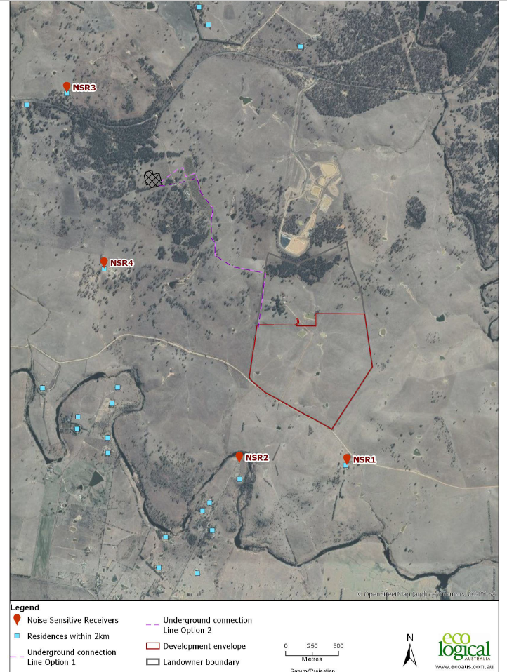
Figure 11 – Location of closest Noise Sensitive Receivers (NSR)

(iiia) the provisions of any planning agreement that has been entered into under section 7.4, or any draft planning agreement that a developer has offered to enter into under section 7.4
Not applicable.
(iv) the provisions of the regulations
Relevant Clauses of the Regulations have been considered during the assessment of this proposal.

4.15 (b) the likely impacts of the development, including environmental impacts on both the natural and built environments, and social and economic impacts in the locality

This assessment has been undertaken having regard to various issues, as follows:
Biodiversity:
The proposed development has been assessed using the BAM established under s6.7 of the Biodiversity Conservation Act 2016, which has established that a BDAR is required to be prepared in support of the application.
The BDAR is required in order to assess the impacts to biodiversity, propose mitigating and ameliorating options, as well as calculate offsets for unavoidable residual impacts.
The Development Site covers an area of approximately 94 ha and is situated on a beef and lamb agricultural enterprise, which contains limited native biodiversity. The Development Site is adjacent to the Armidale Waste Facility to the north, paddocks to the east and west, and by Gara Road to the south. The Development Site has been subject to past native vegetation clearing typical of the New England region.
The Applicant has advised that:
The current Proposal has considered the biodiversity values known to occur within the Site, and has where possible avoided areas of native vegetation, threatened species, and their habitats. In particular, the Proposal has avoided (as far as practicable) areas of Threatened Ecological Communities (TECs) and known threatened species habitats. The Site has reduced through each iteration of design, to provide a final footprint that:

• Co-locates the grid transmission network infrastructure;
• Locates panel arrays within areas of cultivation; and
• As far as practicable avoids drainage lines, high quality vegetation, and known threatened species records.
The placement of the Development Site footprint has centred around the area of lowest biodiversity value within the development boundary, avoiding more established woodland areas.
The Assessment did not identify the presence of any definable Plant Community Types (PCTs) within the Development Site, with the development footprint being assessed as being poor condition grasslands that are dominated by exotic species.
It further states that:
One threatened flora species, Dichanthium setosum (Bluegrass) has been recorded within the development site, in two discrete patches. No threatened fauna species have been recorded within the Development Site.
Biodiversity- (Cont):
Development works associated with this BDAR assessment will require the disturbance and modification of grasslands to facilitate development of a solar farm. Connection points between the solar farm and the sub-station area have been drafted to avoid all impacts to woodland vegetation.
In conclusions the residual unavoidable impacts of the project were calculated in accordance with the BAM by utilising the Biodiversity Assessment Method Credit Calculator (BAMC). This is based on the clearing of all vegetation within the Development Site, which is a conservative estimation given the likely outcomes of a solar farm development, which will allow grassland communities to persist in the future. The BAMC calculated based on a worst case scenario, is precautionary in nature, and that no ecosystem credits are required to offset the unavoidable impacts to native vegetation present on the development site. Based on the assumed presence of the species credits identified above, three (3) species credits would be required for impacts to threatened species habitat.
Following Council’s initial assessment of the proposal and after reviewing comments received from RMS, it was identified that additional clearing of native vegetation may be required for both the intersection upgrade at Gara and Grafton Roads as well as the upgrade to the entrance of 1060 Grafton Road, which had not been taken into consideration during the initial BDAR. As such, additional information was requested from the Applicant as part of a further information request, requiring an addendum to the BDAR be provided following the assessment of potential impacts on biodiversity as a result of any road upgrades.
In response, the following information was provided to Council which identified the particular impacts from vegetation removal in these localities:
Based on the upgrade of Intersection 1, up to 0.03 ha of native vegetation, which is consistent with PCT510 will be impacted. This includes 0.03 ha which is consistent with White Box Yellow Box Blakely’s Red Gum Woodland which is listed under the Biodiversity Conservation Act 2016 (BC Act) as an Endangered Ecological Community (EEC). This also includes 0.03 ha which is consistent with the Commonwealth Environment Protection and Biodiversity Conservation Act 1999 (EPBC Act) Critically Endangered Ecological Community (CEEC) White box - yellow box - Blakely's red gum grassy woodlands and derived native grasslands. Measures to reduce the extent of impacts at Intersection 1 have been previously proposed, including developing a Traffic Management Plan to reduce the requirement for road upgrades.
Based on the upgrade of Intersection 2, up to 0.01 ha of native vegetation, which is consistent with PCT568 will be impacted. This community is not listed under either the BC Act or EPBC Act. This vegetation does however provide habitat for native fauna, and any design changes that reduce the area of impact would be beneficial to biodiversity. The addition of these two intersections increases the biodiversity impact of the project.
Based on the inclusion of these two new areas to the assessment, the following impacts and credit requirements are presented in the table below. These credits are to be retired in accordance with the conditions of consent for the overall project (i.e. Stringybark Solar Farm). These credits can be retired via any method as specified in the Biodiversity Conservation Regulation.
The retirement of the above credits can be included as part of a condition on any consent.
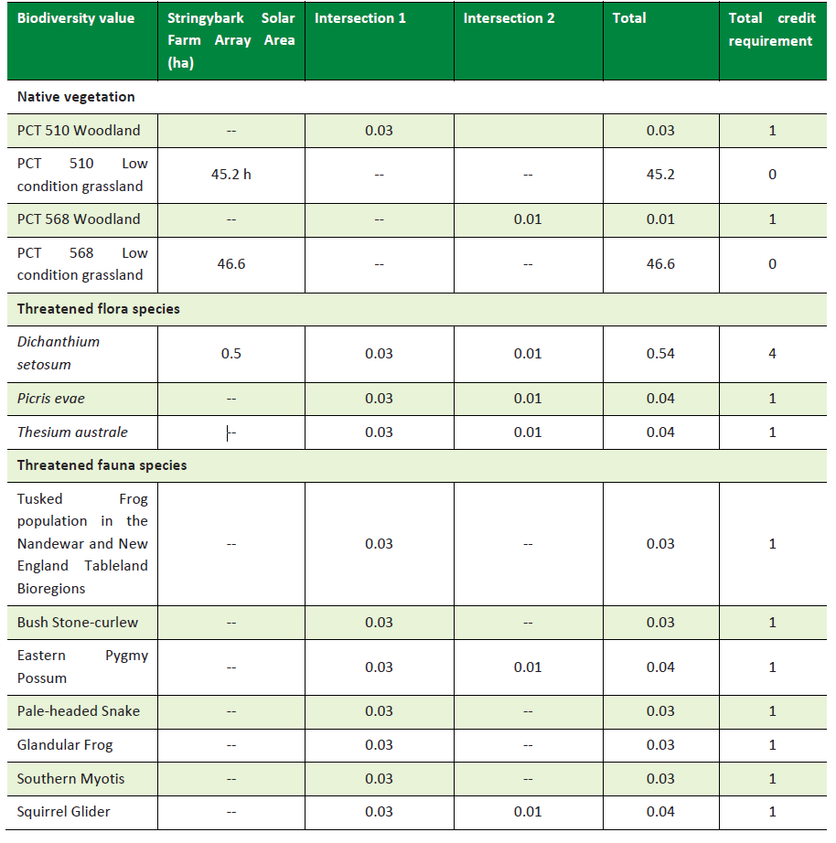
Figure 12 – Biodiversity Impacts

Traffic impacts:
An assessment of any potential traffic impacts from the development has been assessed by both the RMS, whose comments have been provided above, and Council’s Development Engineer whose comments are provided below:
Gara Road:
A Traffic Impact Report was completed as part of the proposed development. The report did not undertake traffic counts but concludes that Gara Road “is suitable for the Project related traffic as it currently caters for semi-trailer cattle trucks that access the Sherraloy property” and that ”Gara Road is of suitable quality to support the low level of construction traffic generated as a consequence of the development”.
Council has survey data for Gara Road (taken on Gara Road from the intersection with Grafton Road) from 2007. Whilst the data is now over 12 years old, it is assumed that traffic numbers have not increased significantly along this road.
The average daily traffic movements along Gara Road were recorded at 108 vpd. Approximately 9% of these vehicles were greater than class 3 vehicle (heavy vehicle) which concludes that approximately 9vpd are heavy vehicles. This provides evidence that Gara Road can already accommodate heavy vehicle movements. The development will generate 10 additional heavy vehicle movements per day during the nine month construction phase.
Gara Road is an unsealed road with some tight horizontal curves, blind crests and three causeways. A site investigation with the Council’s Manager of Roads, determined that Gara Road, with these existing hazards, should still be able to cater for the additional traffic generated by this development. This determination was further supported by Council outdoor staff who have manoeuvred heavy articulated vehicles along Gara Road with success.
Traffic numbers existing and generated will still be low enough to ensure continued traffic flows along Gara Road throughout the extent of the construction phase. Council’s survey data describes the 85th% speed at 37km/h for an unsignposted speed of 100km/h. The current condition of Gara Road limits speeds to 50km/h. Current road conditions will continue to limit speeds and improve driver safety throughout the construction phase of the development.
Gara Road will be able to cater for the additional heavy vehicle movements over the nine month construction period. An additional 14 light vehicle movements during the operational period will be able to be supported by Gara Road.
A road safety audit was undertaken as part of the traffic impact report. The audit identified numerous existing deficiencies (Corrective Action Requests (CAR)). The road safety audit categorised most of these CARs as low or medium risk and three high risk issues. These high risk issues included a steep batter at a causeway, a headwall close to the road edge and a missing signpost at a vertical crest. The Traffic Impact Report concludes that Gara Road is of a ‘suitable quality to support the low level of construction traffic’ and that additional safety measures will be implemented during the construction phase, captured through a Construction Traffic Management Plan.

Traffic impacts – (Cont):
Gara Road- (cont):
Addressing all the Corrective Action Requests (CAR) issues identified in the audit would require significant upgrading to the majority of Gara Road (i.e. steep batters, vertical and horizontal curves, road re-alignment and sealing). This type of upgrade would impose an unreasonable condition upon the development, when considering the minor increase in vehicle movements for a limited nine month construction period.
The low and medium issues identified will instead be flagged with Council’s road maintenance team and road upgrades should be undertaken by Council at a point in time when maintenance programming permits it. It is though recommended that the three high risk issues be included as a condition of any consent.
A sight inspection of Gara Road also identified two medium risks that should also be addressed as part of the development to help improve overall driver safety. This includes a ‘crest ahead’ sign and ‘hidden driveway’ sign to be erected at the approach to 300 Gara Road for western bound traffic and the reduction in batter grades at both approaches to the Burying Ground Creek Causeway to improve driver visibility.
Gara Road in its current condition should be able to cater for the additional heavy vehicle movements over the nine month construction period. An additional 14 light vehicle movements during the operational period will be able to be supported by Gara Road in its current form. Addressing the high risk issues and two medium risk issues will further improve the driver safety for all road uses during and post construction. A Construction Traffic Management Plan will also be required to be completed as part of the development for the construction phase. This will include a dilapidation report to be undertaken pre and post construction, as well as dust mitigation measures and driver code of conduct plans. These requirements are deemed a reasonable imposition on the development when deliberating the current state of Gara Road and the minor increase in traffic movements.
Traffic impacts – (Cont):
Grafton Road:
RMS have commented on the development from the perspective of impacts on the classified road. RMS will require the upgrade of Grafton Road/Gara Road intersection to a rural BAL and BAR. The driveway entrance that will service the substation will be required to be upgraded to an RMS rural driveway crossover standard and be sealed for at least 30m.
RECOMMENDED CONDITION:
The high risk rated CARs identified in the Road Safety Audit (Stage 5 – Road Safety Audit: Stringy Back Solar Farm Transportation Route Revision 2, Constructive Solutions Pty Ltd, 24/07/2019) are to be actioned and fixed to improve driver safety. Additional improvement measures include a ‘crest ahead’ sign and ‘hidden driveway’ sign to be erected at the approach to 300 Gara Road for western bound traffic and the reduction in batter grades at both approaches to the Burying Ground Creek Causeway to improve driver visibility.
Works to be approved through a Construction Certificate. Works to be completed prior to the solar farm construction phase commencing.
A Construction Traffic Management Plan is to be prepared by the applicant. To include dilapidation report and dust suppression measures.
Grafton Road/Gara Road intersection to be upgraded to Austroads standard rural BAL and BAR intersections.
Driveway crossover to substation to be upgraded to an RMS rural driveway crossover and be sealed for at least 30m.

Land Use conflicts
The approximate life span of the proposal is 30 years. Given the relatively small footprint of the proposal, approximately 94ha, across the broader landscape, it is considered that the development will not compromise or significantly diminish the availability of land for agricultural purposes within the region nor would it compromise the capability of any adjoining land uses. Furthermore, given the relatively passive nature of the land use for the purposes of harvesting sunshine in is considered that the proposal would be unlikely to adversely impact on any significant World Heritage Areas and/or National Parks and recreation areas in the locality.
The proposed development which will utilise approximately 94ha of agricultural land over a relatively short time frame before it can be readily returned for agricultural purposes, represents approximately only 0.01% of the total land area within the Armidale LGA and as such is unlikely to adversely impact in the overall productivity of the agricultural sector in the region.

Construction Impacts:

It is recommended that a detailed construction management plan (CMP) be included as a condition of any consent. This would need to address but not limited to, issues such as:
- Hours of building work (to be consistent with NSW State Guidelines);
- Parking and Traffic Management;
- Waste storage and management;
- Toilet facilities;
- Noise and dust management and control of other potential pollutants;
- Site hoardings and public/worker safety;
- Signage.

Socioeconomic Impacts/Benefits:
The proposed development represents a further significant investment into the renewable energy sector within the Armidale region. Such development aligns with strategic documents for the New England North West and is generally consistent with community values, which broadly supports investment and growth in renewables to transition away from our current reliance on carbon intensive energy which has been linked to contributing to climate change.
The Applicant estimates that:
the Proposal would produce approximately 64 GWh of clean renewable energy to the local electricity transmission network (AMEC, 2018). This would provide enough energy to power up to 15,000 NSW homes each year, and in doing so would reduce approximately 53,000 tonnes of CO2 per annum through the displacement of conventional electricity supply.
The proposed development is expected to bring with it social and economic benefits both during the construction phase with the creation of approximately 60 full time jobs over the anticipated 9 month construction phase, plus the multiplier flow on benefits for the local economy, and between 3-6 positions during the operational phase of the project. Some of the indirect benefits that can flow on to the local economy from the development include opportunities for road building/upgrades, transport and logistics, tree planting services, fencing, water supply, equipment hire, specialist consultants, trades and accommodation, to name a few.
In addition, the Applicant states that it is widely recognised that increasing the proportion of electricity generated from renewable energy will have the effect of reducing electricity prices for end users (AEMC, 2018). While it is not asserted that this project in isolation would reduce electricity prices, if constructed it would contribute to this end. Note, a reduction in electricity prices would not only benefit consumers within the Armidale Regional LGA but would have a positive effect on the economy as a whole.
Agronomy:

The Applicant has submitted an agronomy assessment to identify any potential impacts from the development on the land.

The assessment likens the installation of the supporting structure for the solar panels, which will be a series of piles which will be either mechanical piled into the ground or screwed, to that for the installation of a trellis system for vineyards or orchard, and as such would not involve the complete removal of groundcover within the Development Envelope.

Given that the minimum distance between each of the rows of panels would be 5.5m, groundcover in this area would remain and provide potential feed for grazing if required. Additionally, as the panels will track the sun throughout the day it is expected that the groundcover will also remain and grow under the arrays themselves.

Given the above the Assessment considers that the development would result in any large scale soil disturbance as a result of the construction of the solar farm.

The following issues were explored:
• Nature of the soils occurring onsite and the potential for erosion;
• Existing Productivity of the Site
• Effects of removing the Site from agricultural production; and
• The ability to maintain ground cover across the Site to prevent soil erosion during the operation of a solar farm.

Agronomy – (cont):

In response to these matters the agronomy assessment advises the following-

Soil types:

The proposed site for the solar farm is comprised predominantly of what is known locally as “Traprock” soils. Trap soils are a duplex soil type which are generally a fine-grained sedimentary loam overlaying a clay subsoil, or an impervious rock layer. The trap soils do vary widely in their physical properties, fertility, acidity and depth, making them a hard soil type to generalise. The loam topsoil can often set hard, which can be a physical constraint on the usage, and they are also of low to moderate fertility.

Depending on the depth of the loamy layer on top, they can be very pebbly or stony with protruding rock visible in ridges or parallel intervals. Trap soils have a lower potential to erode than the Granite soils of the region, but are not as low as the basalt based soils.

Average Production in current state:

The 90Ha area proposed to go under solar panels would have an overall carrying capacity of approximately 450 DSE. Should this area be taken out of agricultural production, the overall loss to the region would be 450DSE, which equates to 450 dry sheep, or 45 x 400kg steers, which is not a significant loss from the region. It should be noted, that it is possible that some grazing could be continued under the solar panels to maintain grass heights, as such there may not be a 100% loss to agricultural production at the Site. Although it is acknowledged that stocking rates would be significantly reduced.

Once the Site is under solar panels, I see no reason why there would be an increased risk of erosion potential if ground cover at the Site is well maintained. Water being shed off the panels may be more concentrated in heavy rainfall, but it would not be in the same area each time, as the panels will be at different angles depending on the time of the day and where they are tracking.

Species Composition:

The proposed species to establish into the disturbed areas would be Cocksfoot. Cocksfoot is a deep-rooted perennial species that would provide a permanent solution to the site. Cocksfoot is also a species that will tolerate shaded sites, so would provide a solution under the solar panels.

Given this, the proposed development will not adversely impact on any highly important agricultural land, nor will it significantly impact on the overall agricultural production of the region.

Potential for leaching from panels:

During the assessment of this application by Council’s Environmental Officer additional information was requested to address the above matter. Council’s comments to the applicant in regards to this were:
Council comments:
Council has reviewed the environmental pollution components of the Stringybark Solar Farm Statement of Environmental Effects and attempted to cross-reference findings and some concerns raised in public submissions with an array of scholarly scientific literature. While extant literature on solar modules’ contamination of the environment is conflicting on a number of analytic metrics, and on spatiotemporal differences, there are some studies that appear to point toward rainwater-leaching and life-cycle toxicity of cadmium, copper, lead, silver, nickel, tin and zinc from solar modules. For example, silver and zinc were leached from operational intact and damaged solar modules observed for 6 months in Denmark (see Figure 1). Another study showed that copper (I) thiocyanate and lead (II) iodide can leach out quickly during PV use phase.

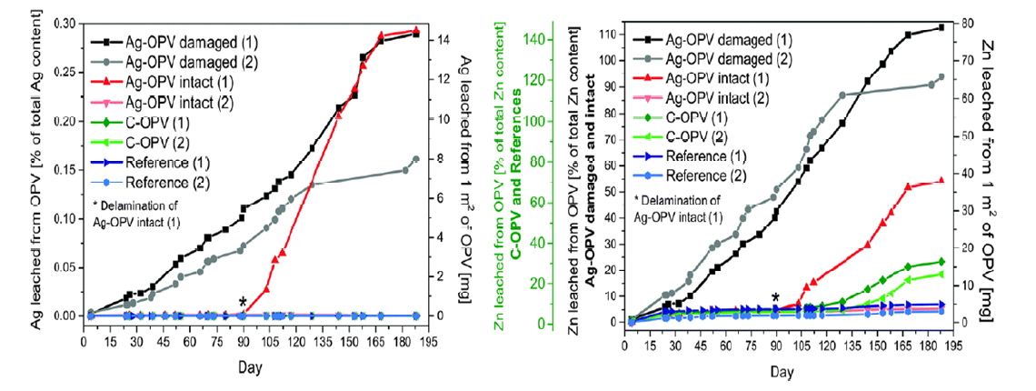Figure 1. Cumulative silver (left) and zinc leaching from the samples in the rain run-off experiment conducted in duplicate. The amounts are expressed in mg per m2 of Organic photovoltaics (OPV) (right axis) and the corresponding share of leached material (left axis).

However, extensive search of databases and currently operational solar farms in Australia and elsewhere reveals inadequate issue-based and data-driven precedents that can support specific decisions – refusal or approval – in cross-examinations and assessments of solar farm development proposals. Pervasive arguments thus far focus on comparing the toxic metal releases of the photovoltaic cells (PVs) to today's coal power plants, where it’s seen that the metal emissions from PVs are expected to be several times less than the emissions from coal. So the cleaner energy race in the present energy mix is a selection of lesser devil, or alternative(s) with least polluting potential.
As such, could you please provide some manufacturing details of the solar panels. It is noted in a number of studies that encapsulation of some PV structural components reduces potential incidence of rainwater-induced leaching. Consequently, newer PVs have solder and other components produced without lead and toxic metals.
Potential for leaching from panels- (cont.):

Proponent response:
There is no clear evidence that the leaching of toxic elements from solar panels during the operational phase is an environmental issue in Australia or abroad. Although there are a number of materials used in the manufacture of Panels that are considered toxic, “for intact PV panels, leaching of these elements is unlikely to occur” because they are encased in a number of protective layers.
During the manufacturing process of a solar panel, the PV cells are typically encapsulated in a clear hardened resin with strengthened glass protecting the front side, as well as a back side made from a polymer such as Tedlar PVF material (Clean Energy Review, 2019). The completed panel is then further protected by an aluminium frame.
These features protect the panel from the environment including extremes in temperature, rainfall, hail and humidity (Clean Energy Review, 2019). A robust design, combined with a standard 25-year warranty (DNV-GL, 2017) ensures that the likelihood of cell material being exposed to the environment is very low. Indeed, discussions with manufacturers on this point support this view, with one Australian manufacturer stating that: “In a high-quality module, the encapsulant prevents the deterioration and emission of these elements from the module”.
Nonetheless, the following procedures would be adopted to ensure that; firstly, panels are unlikely to become structurally compromised; and secondly, if panels do become compromised, potential environmental effects will be avoided:

1. Due Diligence Process:
As a minimum, panels should meet the Australian standard AS/NZS 5033 for photovoltaic modules and the international standard IEC 62804 (Clean Energy Council, 2018); panels should be backed by a 25 year warranty (DNVGL, 2017); and panels should be tested and checked for structural deficiencies (particularly after delivery to site and before installation).
2. Robust operational protocols governing procedures for ensuring panel integrity:
The Operation Environmental Management Plan (OMEP) would include clear provisions for routinely checking panels to ensure structural integrity and performance throughout the operational period. Any panel found to be defective would be assessed and dealt with in line with the requirements of the WARR (2001) and POEO (2014) Acts.

It is recommended that a condition be included on any consent to address the above undertaking by the Applicant in regards to due diligence and operational protocols.
Visual Impacts:
The Applicant has submitted a Landscape and Visual Impact Assessment with the application which along with assessing the potential landscape and visual impacts of the proposal, it has also included the potential for any solar glare. The assessment includes photomontages prepared for the proposal which the Applicant states, demonstrates that the proposed solar array would not be a dominant feature in the landscape.
The Applicants consultant further states that, the presence of renewable energy projects will change some perceptions of the landscape character of a locality. However, to assume that the introduction of a solar farm to a landscape will create irreversible damage to landscape values and negatively impact the amenity of the area is not substantiated in statistical data in community perception studies from Australia and overseas.
Previous studies have found that there was widespread support for large scale solar energy facilities in Australia, with 78% of respondents indicating their support. This is similar the views expressed during community consultation for the Stringy Bark Solar Farm.
In 2015 the OEH commissioned the Community Attitudes to Renewable Energy in NSW, 2015 which included solar farms as part of the diversified renewable energy platform for NSW.
When asked the question regarding the acceptance of wind and solar farms within 1-2 kilometers of a dwelling, the response for solar farms received support in the order of 91%.
Firstly, it must be clarified that the Stringybark Solar farm is proposed to be located on land zoned RU1 Primary Production and that the adjoining zone to which many submissions have been received in the Castedoyle, Milne and Andersons Roads area are all within the RU4 Primary Production Small Lots zone, both of which are not considered to be rural residential zonings.
Potential impacts on views from the proposed development on properties within the locality has been a the subject of significant concern raised in the submissions, which have stated that the proposed development will dominate the landscape, be visually intrusive and adversely impact on the rural character of the area.
In this regard, a persons perception on a developments potential to impact on views is particularly subjective. Whilst a majority of these submissions acknowledged the benefits of solar energy and that as a nation we needed to embrace these new technologies and move away from our reliance on fossil fuels, they did not want them located within view of a rural dwelling and suggested that they should be located out of site in isolated areas.
The site of the proposed Development Envelope and associated infrastructure, will be located on an already modified area of the property which is not considered as untouched or pristine land. As such, the proposed development area is on land that is not particularly rare, of significant scenic quality or of high biodiversity value.
Furthermore, whilst it is not argued that views are valued by some people they are not protected and preserved in perpetuity for ones own enjoyment, with the owner of that land having the right to undertake changes over time whether they may be permitted without consent within the zone or subject to consent. As such, changes to farming practices or the introduction of more intensive farming may change the landscape at any time.
There is also the argument that no one owns a view and this matter is discussed in more detail below in relation to the planning principle in regards to views and view sharing handed down by the Land and Environment.

Visual Impacts –(cont.):
In conclusion and after assessing publicly accessible and residential viewpoints with visibility of the Development, the Landscape and Visual Impact Assessment rated the impacts on these particular locations as negligible to low.
The assessment of potential glare from the development concluded that there were no locations where solar glare of any magnitude is predicted.
Additionally, there has been fairly extensive case law handed down by the Land and Environment Court in regards to a developments impact on views. When establishing consistency of decisions and planning principles in regards to impacts on views, the principles to be considered when assessing this were set out by Roseth SC in the landmark case Tenacity Consulting v Warringah Council 2004.
Out of this particular case, it is advised that the Land and Environment Court established a four-step assessment to decide whether an impact on views is reasonable.
The Senior Commissioner for the above hearing adopted the following four step assessment in deciding whether the impacts on a view were reasonable:
1. The first step is the assessment of views to be affected. Water views are valued more highly than land views. Iconic views (eg of the Opera House, the Harbour Bridge or North Head) are valued more highly than views without icons. Whole views are valued more highly than partial views, eg a water view in which the interface between land and water is visible is more valuable than one in which it is obscured.
In regards to the Courts first step of the assessment, reference to icons and iconic views needs to be considered in context to the locality of the site and what may be considered as iconic in that setting. In this regard, whilst the views from the south of the site may be considered to be highly valued by residents and uninterrupted they are not considered to be iconic when considered under the first step. Furthermore, the proposed development would not totally remove/take away all views over rural land from these properties as views would still be visible over rural landholdings to the north-east and north-west, with the Development Envelope only occupying a relatively small arc in the view corridor.
2. The second step is to consider from what part of the property the views are obtained. For example the protection of views across side boundaries is more difficult than the protection of views from front and rear boundaries. In addition, whether the view is enjoyed from a standing or sitting position may also be relevant. Sitting views are more difficult to protect than standing views. The expectation to retain side views and sitting views is often unrealistic.
In this regard, many of the views from adjoining properties would be over side boundaries given the orientation of the lots which face into Andersons and Milne Roads, which run in a north/south direction. Again it would only be visible from certain locations on those properties it is unclear whether these would be sitting or standing views.
3. The third step is to assess the extent of the impact. This should be done for the whole of the property, not just for the view that is affected. The impact on views from living areas is more significant than from bedrooms or service areas (though views from kitchens are highly valued because people spend so much time in them). The impact may be assessed quantitatively, but in many cases this can be meaningless. For example, it is unhelpful to say that the view loss is 20% if it includes one of the sails of the Opera House. It is usually more useful to assess the view loss qualitatively as negligible, minor, moderate, severe or devastating.
Visual Impacts –(cont.):
As above, views over the proposed Development Site would only be from specific locations on properties within a 2km radius. Any views beyond this distance would be considered to be negligible.
4. The fourth step is to assess the reasonableness of the proposal that is causing the impact. A development that complies with all planning controls would be considered more reasonable than one that breaches them. Where an impact on views arises as a result of non-compliance with one or more planning controls, even a moderate impact may be considered unreasonable. With a complying proposal, the question should be asked whether a more skilful design could provide the applicant with the same development potential and amenity and reduce the impact on the views of neighbours. If the answer to that question is no, then the view impact of a complying development would probably be considered acceptable and the view sharing reasonable.
As per the above assessment, it is considered that the proposal complies with relevant planning controls and is permissible with consent within the zone. In regards to views and the possibility of alternative sites for the development, it is considered that the Applicant and consultants have undertaken a fairly rigour site selection analysis to identify the optimal location on the site for the development whilst minimising impacts where possible.
In this regard, it is also worth noting that the Applicant has submitted the application for the development on the subject site not another site. As such, Council is bound to assess the development as submitted and whether it complies with relevant planning controls.

Bushfire
The subject site for the siting of the solar arrays and substation are not identified on Council’s current Bushfire Prone Land Map as being potentially bushfire prone. However, some areas where the cabling will be located and an area directly adjoining the location for the substation are identified as being potentially bushfire prone.
The proposal does not require a Bush Fire Safety Authority from the Commissioner of the NSW Rural Fire Service (NSW RFS) under section 100B of the Rural Fires Act.
The site for the proposed development is largely devoid of tree cover and is located on cleared areas of the landholding with only ground cover. With the removal of stock from the Development Envelope area on the site there is the potential for an increase in fuel loads which could lead to grassfires if not effectively managed through mitigation measures.
There is also the potential for ignition sources during the construction phase with the movement of machinery, use of welders and grinders and the like, storage of flammable liquids, electrical faults, lightning strikes and cigarette butts. Like any activity being undertaken in potentially bushfire prone areas these matters will need to be clearly identified and managed on site in the preparation of a Bushfire Management Plan in consultation with relevant fire authorities.
The flammability of the solar farm is considered to be relatively low as they are predominantly constructed of glass, silicon, steel and aluminium.
Even so, the Applicant has proposed to implement the following measures which can be included as a condition in any consent.
A suite of mitigation measures are proposed to reduce and manage the risk of fire, and to reduce the impact of any fires within or surrounding the Proposal (Section 7.10.4), including:
• Design and installation principles and features;
• Firebreaks and other design features that will be developed in consultation with relevant fire management agencies (including the NSW RFS);
• Fuel load reduction;
• Fire management and emergency response strategies will be included in an Emergency Response Plan (ERP) for each phase of the development and will be prepared in consultation with and distributed to NSW RFS and NSW Fire and Rescue; and
• Safety protocols.

CUMULATIVE IMPACTS:

It is noted that there are currently a number of major / renewable projects in the locality of the subject site, both local and SSD, which are identified in the table and Figures 14 & 15 below.
Project | Approximate Distance and Direction from Site | Development Phase
Oxley Solar Farm (300 MW, with 30 MWh battery storage capacity) | Investigation area adjoins the eastern boundary of the Stringybark Solar Farm Site | Secretary’s Environmental Assessment Requirements (SEARs) issued for SSD
Armidale Waste Facility | 310 m NE | Soon to be commissioned, with fulltime operational activities commencing in 2020
Olive Grove Solar Farm | 300 m NE | Pre-DA consultations with Armidale Regional Council
Metz Solar Farm (100 MW) | 9 km NE | Under Construction
Armidale High School | 12 km W | Approved and under Construction
UNE Wright Block Student Housing & Hub Building | 13 km NW | SEARs issued for SSD
New England Solar Farm (720 MW with energy storage) | 18 km SW | More information required for Recommendation
Sailsbury Solar Farm | 19 km SW | SEARs being prepared for SSD
Tilbuster Solar Farm (300 MW) | 19 km NW | SEARs issued for SSD
Petersons Solar Farm (5 MW) | 9km W | Application lodged with Council

Given the above projects, either approved and/ under construction or currently being assessed or scoped, there is the potential for cumulative impacts within Armidale and the locality if these developments coincide during construction and during operation.

Whilst it is acknowledged that at this time this is the only solar farm project proposed along Gara Road it is noted that there is the potential for another two solar farm project to be located adjoining the site with both the Oxley Solar Farm obtaining their SEARs for the development and Olive Grove Solar Farm currently preparing their documentation for the lodgement of an application with Council.

Each of these projects will be assessed on their merits in regards to their potential impacts on the subject land, land use conflicts, heritage both European and Aboriginal, biodiversity, water, air, waste and bushfire etc and are not anticipated to have a cumulative impact on these matters that can not be satisfactorily addressed individually within each particular site to negate any cumulative affects.

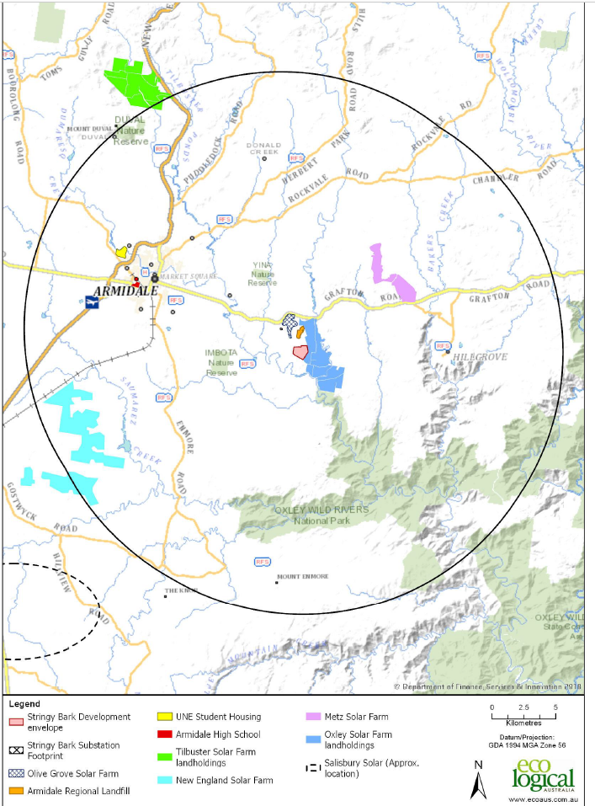
Figure 14 - Location of major and renewable energy projects within the immediate region

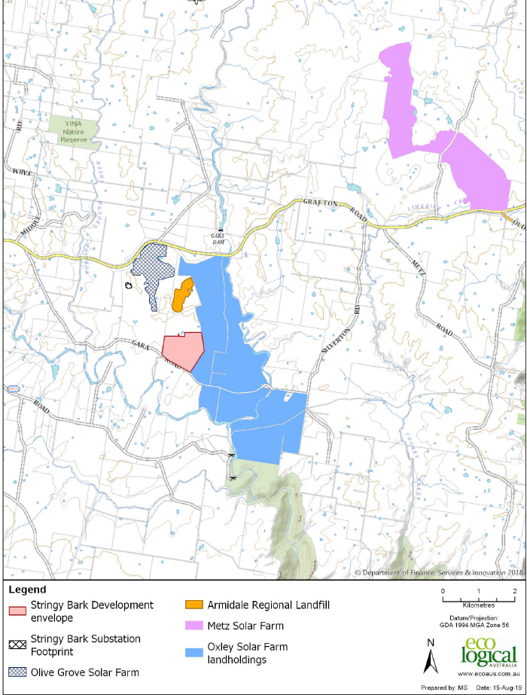

Figure 15 – Location of nearby projects within immediate locality and local road network

Traffic:

Whilst Olive Grove and Oxley solar farms adjoin the subject site, it is advised that other than this particular development only Oxley will have the potential to utilise Gara Road for access to their site, as Olive Grove will be accessed directly off Grafton Road. It is currently unclear whether Oxley will access the site from Gara Road or whether they will access via Grafton Road as the site also adjoins this classified roadway, as the development is still being scoped and has yet to be lodged with the Department as a SSD.

Given that Oxley solar farm is still some time off from actually lodging an application it is unclear whether both projects would ever coincide and as such, impact further on traffic and local roads.

Metz solar farm has commenced construction with an estimated construction period of 12 months and would therefore be unlikely to coincide with any of the other solar farm developments in Figure 15, either lodged or proposed.

As Grafton Road is a classified state road it is considered that there would be adequate capacity on this roadway if construction of these other three solar farms coincided. Any access off Grafton Road for these developments would be subject to a separate assessment by Council and the RMS regarding any upgrades required.

Any potential cumulative impacts on Gara Road from further developments are difficult to accurately quantify at this time without specifics in regards to final size of any proposed development, preferred access arrangements and whether both developments would ever coincide.

In this regard, Council’s Development Engineer has advised that Gara Road will be suitable subject to upgrades as detailed above for the Stringybark solar farm given that it is for a relatively moderate sized proposal in comparison to other solar projects and that the construction period is over a relatively short period of time.

As such, Council’s Development Engineer has advised that the sealing of Gara Road is not required for the Stringybark development but this may not be the case when any future solar farm in the locality is ever proposed, which will be assessed on its merits at the time, taking into consideration such matters as the size of the project, number of vehicle movements and construction period.

Visual and Cumulative Impacts on views:

At the time of this assessment of the Stringybark Solar Farm, both Olive Grove and Oxley Solar farms are currently being scoped, so it is difficult to accurately assess any cumulative visual impacts on views in the locality from the three solar farms. Metz solar farm is approximately 8km away from this proposal and is considered to be sufficiently removed from these three sites, and as such unlikely to contribute to visual impacts in this particular locality.

The Olive Grove solar farm will be located approximately 750m to the north of the Development Envelope for the arrays and lies within an area that is not visible from the Stringybark proposal and will therefore not contribute to cumulative visual impacts. The substation is also screened from view from the south and located a substantial distance from any receptors.

The proposed 300MW Oxley Solar Farm adjoins the eastern boundary of the subject site and has received SEARs from the Department of Planning, Industry and Environment (DPIE). The siting of the development on the site though is still being developed and is unclear at this time.

Apart from the potential cumulative impacts from traffic discussed above, there is also the potential for cumulative visual impacts within the viewshed.

The Applicant has defined the viewshed as being within 500m from the Site’s boundary. Beyond this distance it is considered that whilst the Proposal may be noticeable from properties further away it will not dominate the views as this would dissipate as distance from the Site increases.

Furthermore, it is also agreed that the potential for cumulative impacts from properties would be at select locations only, where both developments could be visible from the same site. There is the potential for this to occur at some locations but it is considered that such impacts would be limited and negligible.

DPIE has recently released a guideline, dated December 2018, for the assessment of large scale solar energy developments. Whilst it is noted that the guidelines have been developed for the assessment and determination of SSD it is considered that the guidelines are useful in this instance when assessing the potential cumulative impacts of both developments, one of which will be SSD and this proposal being just under the threshold.

The objectives of the guidelines are:
- provide guidance to the community, applicants, industry and regulators on how the Department of Planning and Environment (the Department) assesses environmental, social and economic impacts of State significant solar energy projects;
- encourage industry to select suitable sites for projects to reduce the likelihood and extent of land use conflicts and environmental and social impacts;
- facilitate better on-ground outcomes by promoting early identification of potential impacts;
- promote meaningful, respectful and effective community and stakeholder engagement;
- support the development of a sustainable solar industry in NSW by providing a clear, consistent and responsive policy framework.

The Guidelines state that:

Australia has the highest average solar radiation per square metre of any continent in the world. NSW has an abundance of excellent solar resources and established electricity infrastructure that, along with declining technology costs, makes it an attractive location for solar energy development.

It also acknowledges that a sustainable solar energy industry in NSW will help to reduce our reliance on fossil fuels whilst providing jobs and investment in regional NSW.
Visual and Cumulative Impacts on views - (cont.):

The Guideline advises of the importance of good site selection to avoid and minimise negative impacts from the outset. It further states:

The Department understands that there are many technical and commercial factors that applicants consider when selecting a site for a solar development. These include the proximity to the electricity network, available connection capacity or distance to towns, cities or other major energy users.

The key site constraints have been identified as being:
- Visibility and topography

sites with high visibility, such as those on prominent or high ground positions, or sites which are located in a valley with elevated nearby residences with views toward the site. This is particularly important in the context of significant scenic, historic or cultural landscapes.

In this regard, the Applicant has taken these matters into consideration during an extensive scoping assessment, which included public consultation, to identify particular site constraints to refine the proposal to minimise its impact on biodiversity, landscapes, archaeological concerns and views. The proposal has been reduced in area and location so as not to locate the development on ridge tops/high ground to reduce visual dominance in the landscape.

In this regard, the Development Envelope itself has been moved lower down the slope so as to reduce its visibility and ensure that it is placed well below any ridge tops, which will retain the existing vegetation.

Additional landscaping is also proposed around the southern /western boundary of the array area to provide a further visual screen of the development.
- Biodiversity

areas of native vegetation or habitat of threatened species or ecological communities within and adjacent to the site, including native forests, rainforests, woodlands, wetlands, heathlands, shrublands, grasslands and geological features.

The Applicant has taken biodiversity constraints on the lots into consideration during the scoping of the development which has identified the appropriate location in order to minimise impacts on any significant areas of native vegetation that may be present. From this scoping and site analysis, the Applicant has identified the least significant areas on the lots to locate the proposed development.
- Residences

residential zones or urbanised areas.

Whilst there are residential dwellings located within 2km of the Site, none are located in any residential zones or what could be described as urbanised areas. All dwellings within 2km of the Site are located either within the RU1 ‘Primary Production’ zone or RU4 ‘Primary Production Small Lots’ zone.
- Natural hazards

areas subject to natural hazards such as flooding and land instability.

Apart from the potential for bushfire affecting part of the overall holding, which has been discussed above, there are no other known natural hazards affecting the Site.

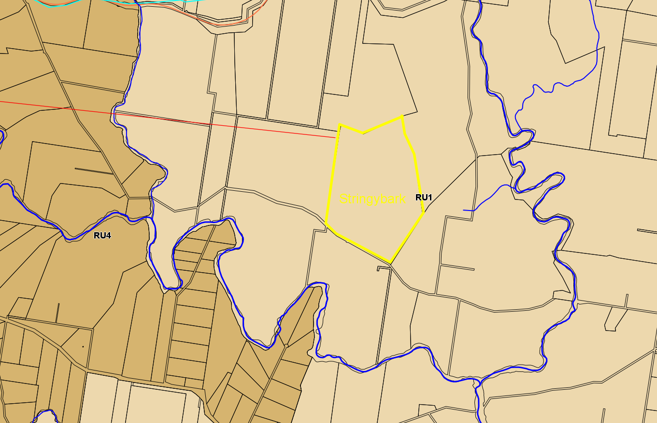

Figure 13 – Extract of ADLEP 20102 zoning map for the locality
- Agriculture

important agricultural lands, including Biophysical Strategic Agricultural Land (BSAL), irrigated cropping land, and land and soil capability classes 1, 2 and 3 . Consideration should also be given to any significant fragmentation or displacement of existing agricultural industries and any cumulative impacts of multiple developments.

As detailed above, the Site is not identified as being important agricultural land, Biophysical Strategic Agricultural Land, irrigated cropping land nor is it considered as land and soil capability class 1, 2 & 3.

Given that the development represents a relatively small area of the overall landholding and the relatively benign nature of the development itself, it is considered that it is unlikely to result in significant fragmentation or displacement of any existing agricultural industries in the locality nor result in any adverse cumulative impacts.
- Resources

prospective resource developments, including areas covered by exploration licences, and mining and petroleum production leases. Solar development applicants should seek advice from the Department of Planning, Division of Resources and Geoscience about the coverage of resources-related licences.

The Applicant has advised that there are no such developments/licences/leases affecting the Site.
- Crown Lands

if any part of the project or associated transmission or distribution infrastructure will cross Crown Lands, it may be subject to legislative requirements that restrict access to the land.

The development, including, cabling, substation and transmission lines are all located oin freehold land. No access to Crown land is required for this Proposal.

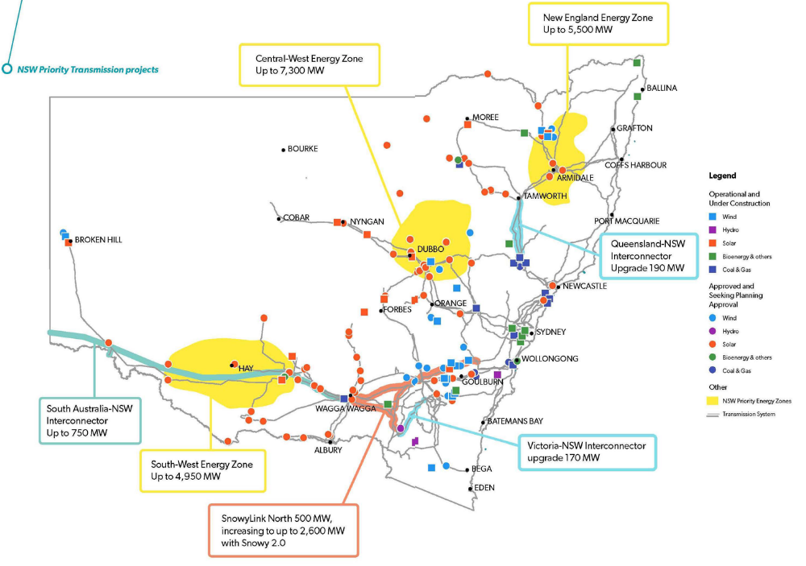

Figure 14 - Renewable Energy Resources Map (Extract from DPE Handout – Large Scale Solar Development)
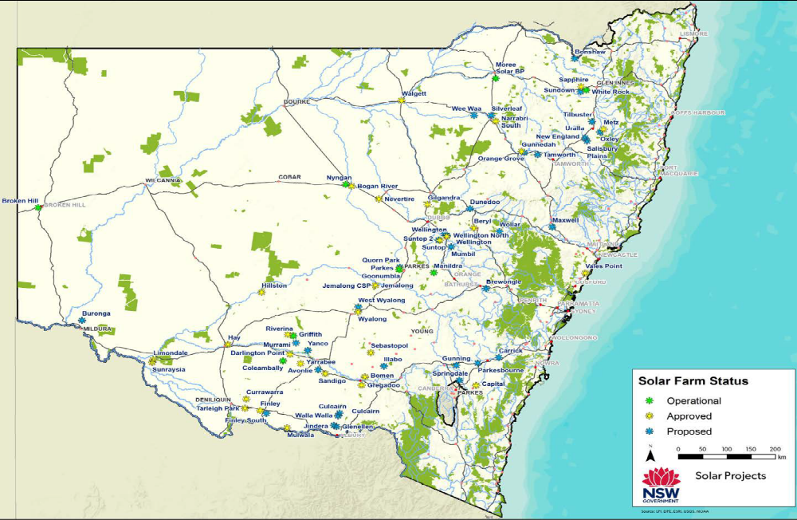
Figure 15 – Solar Farm Status - (Extract from DPE Handout – Large Scale Solar Development)
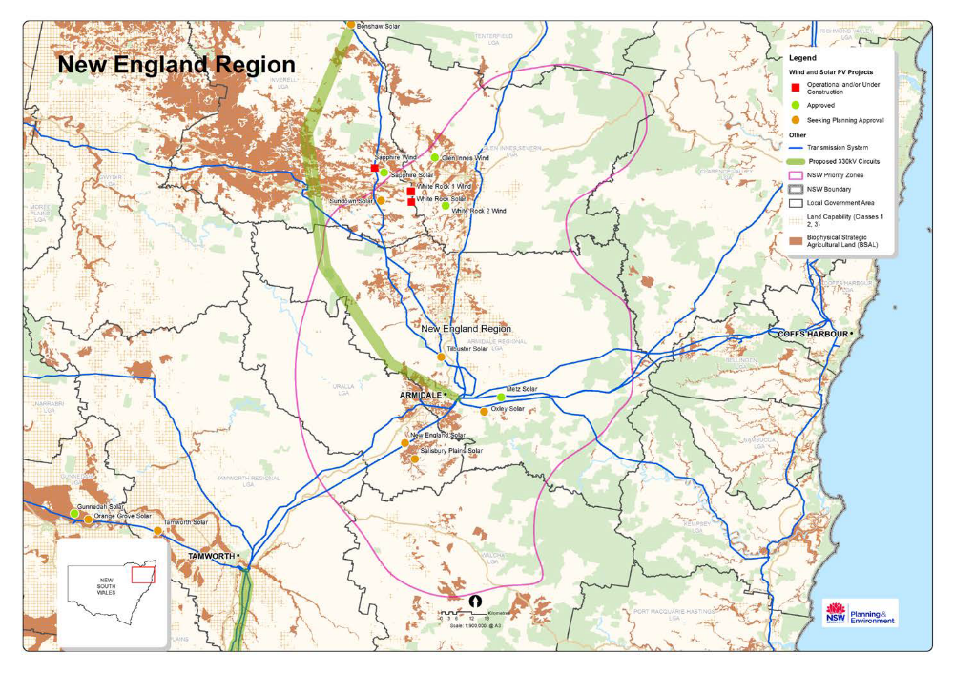
Figure 16 – Renewable Energy Status New England - (Extract from DPE Handout – Large Scale Solar Development)

Noise:

If both developments proceed together there is the potential for cumulative noise impacts on unrelated dwellings. The noise assessment undertaken for the Proposal identified the NSRs to the development and considered that noise from the development could be managed and mitigated to reduce any adverse impacts on these residences. Furthermore, it is considered that noise from the development would largely be limited to the construction phase only.

As the location of the adjoining Oxley Solar Farm development is still largely unknown it is difficult to quantify the potential impact from both developments being constructed simultaneously. In this regard, any construction would be limited to the standard hours of construction being Monday to Friday 7am to 6pm and Saturday 8am to 1pm.

4.15 (c) the suitability of the site for the development
The subject site is considered suitable for the proposed development for the following reasons:
- The land is zoned RU1 Primary Production with the proposed development being permissible under Clause 34 of the ISEPP.
- Given the relative passive nature of the development being for solar harvesting, the proposed development is not considered to be inconsistent with the zone objectives and would be unlikely to result in any land use conflicts or restrict the use of adjoining land.
- The site is not subject to any significant land constraints.
- The site would not impact on higher value agricultural land.
- The Development Site has been located to reduce impacts on native species, biodiversity and heritage.
- The site is located a satisfactory distance from non-related sensitive receivers and as such impacts from the development are expected to be adequately managed on-site with minimal impacts on adjoining properties.

4.15 (d) any submissions made in accordance with the Act or the Regulations
Agency submissions
Refer comments from NRAR and RMS following their assessment of the proposal above.
Public submissions
The submitted DA was publicly exhibited in accordance with Council’s DCP 2012.
The Application was notified for 28 days to property owners within a 2km radius of the subject site and was also advertised in the local newspaper from 21 August 2019 until 18 September 2019. At the conclusion of the notification period 147 submissions were received by Council, approximately 65 of which were from people outside the locality of the subject site and as far afield as Queensland, WA and Frisco in Texas. The submissions were in turn forwarded to the Applicant for consideration. Copies of the letters with personal details removed have been forwarded to the Panel Secretariat.
An assessment of these public submissions is provided in the table below.
Topic | Summary of concerns raised | Applicant’s Response | Council’s Comments
Topic 1 -  Loss of Agricultural Land | 1a. The Proposal would result in a significant loss of agricultural land.  1b. Solar farms should not be located on highly productive land such as the Proposal Site. They should only be located in very unproductive areas where they do not displace agricultural production. | 1a. The Proposal Site of 94 ha represents 0.01% of the total land area within the Armidale LGA. Removal of this portion of land from agricultural production for the 30 year life of the Proposal would result in a negligible reduction in the availability of agricultural land at the local, regional and state levels.  It should be noted, the Proposal does not represent a permanent land use change as there is a clear request in the SEE for a fixed term permit for 30 years, at which time the Proposal would be decommissioned, and the Site returned to a state suitable for agricultural use.  1b. The Proposal has been strategically located outside any land identified by the NSW Government as Biophysical Strategic Agricultural Land (BSAL) (SEE pp 52). BSAL is defined as ‘land with high quality soil and water resources capable of sustaining high levels of productivity’ (DPIE, 2019). As such, in accordance with conclusions made in Section 7.2.2 of the SEE, it is not considered that the Proposal Site is classified as ‘highly productive’ land.  However, while the Proposal Site is not mapped as BSAL, it is acknowledged that the Site is suitable for agriculture. | 1a. Following Council’s assessment of the Application, it is considered the proposed development would not result in a significant loss of agricultural land within the region.  Furthermore, given that the use of the land is relatively temporary in nature, and will not adversely impact on the long term productivity of the land, it can be returned to agricultural use following the term of the lease.  1b. The Site is not identified as being important agricultural land, Biophysical Strategic Agricultural Land, irrigated cropping land nor is it considered as land and soil capability class 1, 2 & 3.  Additionally, the agronomist has stated that the land is of low to moderate fertility and the use of the land for the proposed development would not adversely impact on the regions overall productivity.

Topic | Summary of concerns raised | Applicant’s Response | Council’s Comments
Topic 1 -  Loss of Agricultural Land –(cont) | 1b. (cont)  1c. The displacement of agricultural land for the Proposal would have implications for food security.  1d. Farmers are already in drought, loss of agricultural land would further stress the industry. | 1b. (cont) Nevertheless, it is not considered that the loss of 94 ha (0.01% of the total land area within the Armidale LGA), nor its annual production value of 450 (Dry Sheep Equivalent) DSE (Appendix A), for the 30 year life of the Proposal would result in a meaningful displacement of agricultural production at the local, regional or state level. Further to the information provided in Section 7.2.2 of the SEE, an assessment of the Site’s productivity has been provided by a local agronomist in Appendix A.  The Proposal does not represent a permanent land use change as there is a clear request in the SEE for a 30 year fixed term permit, at which time the Proposal would be decommissioned and the site returned to a state suitable for agricultural use.  Solar farms typically locate on agricultural land because of their need for broad-hectare lots, with limited native vegetation. While it may seem preferable to locate solar farms in remote (‘very unproductive’) environments, this would require extensive new electricity infrastructure to be installed across the landscape to transmit electricity from remote locations to population centres where it is needed. This would result in significant increases to the cost of electricity.  1c. While it is acknowledged that the construction of a solar farm at the Proposal Site would reduce agricultural production (equivalent to 450 DSE per annum, refer Appendix A), it is not considered that the removal of 94 ha of land with ‘low to moderate capacity’ which is not mapped as BSAL would result in a meaningful reduction in food security at the local, regional or national level. Nor would the reduction in agricultural output result in a significant impact to the services that support the agricultural sector at the local, regional or state level.  1d. A change in land use at the Site for the 30 year duration of the Proposal would provide economic diversification at the local level through lease payments to landowners, wage payments to employees and the use of local service providers (see Section 7.14 of the SEE for further details). This diversification would help to strengthen the local economy in times when agricultural activity is low (e.g. during drought conditions). | 1c. The displacement of a relatively small area of rural land to diversify into an alternative source of income for the landowners is unlikely to have adverse implications for food security. Furthermore, nothing has been provided to substantiate such comment.  1d. The proposed development would provide the landowners with an alternative income stream during drought conditions.

Topic | Summary of concerns raised | Applicant’s Response | Council’s Comments
Topic 1 -  Loss of Agricultural Land –(cont) | 1e. The use of the land for a Solar Farm would create a land use conflict.  1f. Grazing sheep within the solar farm would not be viable. | 1e. The Proposal will have a lifespan of 30 years and will not involve permanent changes to the Site. The size of the Site (94) ha will not compromise or significantly diminish the availability of land for primary production purposes within the Armidale Regional LGA. Furthermore, due to sunshine harvesting being a passive land use, the Proposal would not have any offsite impacts that would impact the World Heritage National Park nearby, any BSAL, or the continuation of any of the existing or proposed primary land uses in the surrounding RU1 and RU4 land use zones. Once the Proposal is decommissioned, the land will be returned to a suitable state to permit a return to agricultural use.  A land use conflict analysis based on the DPI’s Living and Working in Rural Areas handbook (Learmonth, Whitehead, Boyd & Fletcher 2017) is presented in Table 7-4 of the SEE.  1f. The SEE states that sheep grazing could be used to assist in vegetation and weed management at the Site. This would offset some of the costs of carrying out these activities using alternative methods. It is not suggested that the sheep grazing would be economically viable in its own right, as it is clear that stocking rates would be lower than under normal greenfield conditions. Rather, sheep grazing could help to offset some of the costs associated with Site maintenance and provide an opportunity to further diversify income (at a much reduced scale) at the Site.  Claims that it is not possible to graze sheep within solar farms are contrary to actual operational evidence, such as the University of Queensland’s 10 ha 3.3 MW solar facility near Gatton, where sheep are successfully utilised to control the pasture that actively grows under the solar panels (Sibson, 2016; Sorensen, 2017). | 1e. The land is currently zoned RU1 Primary Production under ADLEP 2012 and is appropriately zoned for the proposed development which is permissible with consent under the ISEPP.  Given the relatively innocuous nature of the development, which is for the purposes of solar harvesting, the proposed development is unlikely to create a land use conflict within the locality.  1f. Any grazing of sheep within the Development Envelope is only proposed for the control of vegetation and is of secondary nature to the primary use of this area of the site.  Such activity has been proposed and utilised in other solar farm sites and is considered as feasible.

Topic | Summary of concerns raised | Applicant’s Response | Council’s Comments
Topic 1 -  Loss of Agricultural Land –(cont) | 1g. Agricultural production at the Site would support just as many employees as the Proposal would.  1h. The Proposal will impact the agricultural quality of the Proposal Site. As such, the restoration of the Site would be difficult if not impossible due to permanent impacts on soil quality. | 1g. Under the current agricultural regime, the Site provides direct employment for less than 1 full time equivalent position. There would also be some indirect employment generated as a consequence of the current agricultural activities, for example; transport services, agricultural suppliers and contacting services. However, as outlined in Section 7.14 of the SEE, this is less than the estimated 60 equivalent full time construction positions and the 3 to 6 full time operational positions that would be directly generated by the Proposal along with the indirect employment that would be generated over the 30 year lifetime.  1h. There is no evidence to suggest that the establishment and operation of a solar farm would impact the long term agricultural quality of the Site.  While the Site will not be used for agricultural activities during the 30 year life of the Proposal (apart from potential sheep grazing for vegetation control), it would be fully decommissioned and returned to a state suitable for agricultural use at the end of its life. All the physical infrastructure would be removed from Site during decommissioning including:  • The substation;  • Buildings;  • Removal of the solar panels, tracking systems, inverters and cables  • Removal of onsite tracks and fences unless otherwise agreed with the landowner; and  • reinstatement of all disturbed ground.  Section 7.2 of the SEE provides mitigation measures to prevent activities at the Site resulting in contamination.  It is suggested in some submissions that the Proposal would have long term implications on soil quality due to compaction. This is considered unlikely due to the way solar farms are constructed and the management practices used to operate them. While the reasons for such compaction have not been provided, it may be that it has been assumed that compaction would occur during construction when the panels and the tracking systems are installed or during maintenance activities when the solar farm is operational.  As described in the SEE, the panels would be fitted to a single axis tracking system. The tracking system is supported by plies which are typically spaced at intervals between 5 and 10 m along rows. | 1g. The current status of the site does not support this statement. Apart from the owners of these properties there are currently no additional employees involved with agricultural work on the site.  1h. The installation of the panels is by way of driving or mechanically screwing the piles into the ground. As such, there will be no footings required for structural support of the arrays which will result in limited disturbance of the ground/soils.  The substation and all other ancillary structures can be decommissioned once the lease has ended.  This is further supported by documentation submitted by relevantly qualified consultants such as the agronomy assessment which states that the proposal is unlikely to result in large scale soil disturbance.
Topic | Summary of concerns raised | Applicant’s Response | Council’s Comments
Topic 1 -  Loss of Agricultural Land –(cont) | 1h. (cont) - | 1h. (cont) - Piles are usually driven into the ground mechanically in the same way that vineyard posts are installed. However, the piles are not solid like vineyard posts but usually formed in metal (approx. 3 mm) in a Z like or U shaped configuration (see below example in Figure 1).  The piling process is fairly quick, causes little soil disturbance and is usually completed by a small tracked machine that moves systematically along a pre-set GPS coordinate route. The panels are then fitted by hand to a tracking system that sits on top of the piles. Components for this phase of the installation process are usually distributed alongside the rows by small light vehicles. In conclusion, while there will be movement of materials across the Site during construction the activities are unlikely to cause compaction that would result in a reduction in soil quality.  During the operational phase of the Proposal there will be permanent access tracks constructed across the Site. These access tracks will be used to access the Array Area for day to day management. However, it will be necessary to traverse between panel rows, which would not have formed access tracks. This would be required for quality checks, maintenance and panel cleaning activities. These activities will be carried out using light vehicles. As such, it is not considered that the proposed level of traffic would result in soil compaction that would lead to a long term reduction in soil quality.  During operation, grass cover will be maintained across the Site both between and under the panel rows to provide groundcover. The groundcover will stabilise soils preventing soil erosion and will assist in localised water penetration. Should mowing be utilised as a method to control grass growth under the solar panels, the grass will be directly mulched back onto the soil surface therefore building soil organic matter and enhancing carbon capture while improving water infiltration.  The elimination of grazing or a significant reduction in stocking rates would decrease soil disturbance and therefore reduce the erosion, sedimentation and riparian disturbance at the Site resulting from the current land use. In addition, a decrease in fertiliser use and stocking rates would reduce the potential for nutrients to enter surface waters. Appendix A provides detail on the types of grasses that could be utilised at the Site, as well as how they would be successfully established.

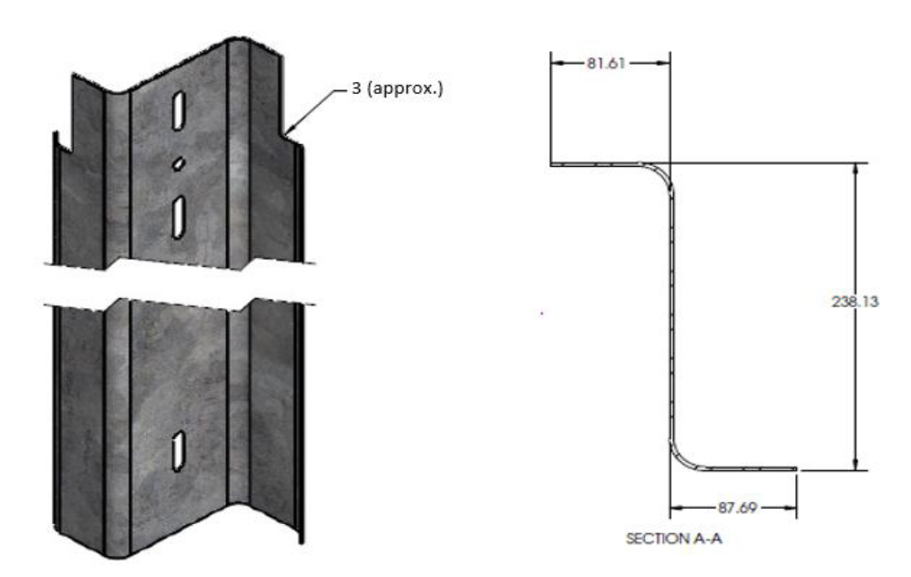
Figure 1: Typical ‘Z’ pile showing form and cross section (measurements in mm)
Topic | Summary of concerns raised | Applicant’s Response | Council’s Comments
Topic 2 -  Decommissioning & Waste Issues | 2a. There is a lack of recycling facilities in Australia, therefore panels may end up in landfill. | 2a. In Australia, despite the industry being relatively young, there is already a commercial scale recycling plant operating in South Australia (Reclaim PV Recycling, https://reclaimpv.com/) and recycling options are expected to increase over time. Components within solar panels, up to 76% glass, (SEE, pg. 113) are readily recyclable with recovery rates increasing as the global industry improves its recycling ability and is increasingly bound by regulation to reduce waste and recycle. As is made clear in the SEE, the Proponent is aware of its responsibilities under the WARR (2001) and POEO (2014) Acts to recover, reuse and recycle waste generated (Section 7.13).  Prior to the decommissioning phase, a Decommissioning Management Plan (DMP) will be prepared. The DMP would identify resource recovery and recycling activities and responsibilities. | A majority of the material that makes up the panel is recyclable. Recycling of these materials already occurs overseas as their renewable industries are now well established.  As such, as the economies of scale for recycling of these materials improves in Australia, it is expected that this industry will grow to ensure that the majority of the material is reused.

Topic | Summary of concerns raised | Applicant’s Response | Council’s Comments
Topic 2 -  Decommissioning & Waste Issues – (cont) | 2b. Panels may leach contaminants into the soil. | 2b. There is no clear evidence that the leaching of toxic elements from solar panels during the operational phase is an environmental issue in Australia or abroad (Robinson and Meindi, 2019). Although there are a number of materials used in the manufacture of Panels that are considered toxic, “for intact PV panels, leaching of these elements is unlikely to occur” because they are encased in a number of protective layers as explained below (Robinson and Meindi, 2019, emphasis added). During the manufacturing process of a solar panel, the PV cells are typically encapsulated in a clear hardened resin with strengthened glass protecting the front side, as well as a back side made from a polymer such as Tedlar PVF material (Clean Energy Review, 2019). The completed panel is then further protected by an aluminium frame. These features protect the panel from the environment including extremes in temperature, rainfall, hail and humidity (Clean Energy Review, 2019). A robust design, combined with a standard 25 year warranty (DNV-GL, 2017) ensures that the likelihood of cell material being exposed to the environment is very low. Indeed, discussions with manufacturers on this point support this view with one Australian manufacturer stating that: “In a high quality module, the encapsulant prevents the deterioration and emission of these elements from the module”.  Nonetheless, the following procedures would be adopted to ensure that; firstly, panels are unlikely to become structurally compromised; and secondly, if panels do become compromised, potential environmental effects will be avoided.  1. Due Diligence Process  As a minimum, panels should meet the Australian standard AS/NZS 5033 for photovoltaic modules and the international standard IEC 62804 (Clean Energy Council, 2018); panels should be backed by a 25 year warranty (DNVGL, 2017); and panels should be tested and checked for structural deficiencies (particularly after delivery to site and before installation).  2. Robust operational protocols governing procedures for checking panel integrity  The Operation Environmental Management Plan (OMEP) would include clear provisions for routinely checking panels to ensure structural integrity and performance throughout the operational period. Any panel found to be defective would be assessed and dealt with in line with the requirements of the WARR (2001) and POEO (2014) Acts (See Section 7.13.3, pg. 113 on panel recycling). | 2b. Further information was requested by Council in regards to this matter. Refer comments above.  Council are satisfied with the Applicant’s response to this concern and recommends that a condition be placed on any consent to ensure ongoing due diligence and operational protocols are adhered to in regards to ensuring panels are replaced if any deficiencies are identified.

Topic | Summary of concerns raised | Applicant’s Response | Council’s Comments
Topic 2 -  Decommissioning & Waste Issues – (cont) | 2c. Panels will require regular replacement.  2d. The Site is unlikely to be decommissioned.  2e. Future owners would not be bound to decommission the Proposal. | 2c. Claims that panels require regular replacing are unsubstantiated. As noted above panels supplied for utility scale solar have standard warranty periods of 25 years (DNV-GL, 2017).  2d. The commitment to decommission the project is explicit throughout the SEE. The development application includes a decommissioning process to be completed within 30 years of the Proposal’s life. It is assumed that the requirement for decommissioning will be a condition of consent. As such, compliance would be required under the EP&A Act.  2e. Compliance with any decommissioning condition attached to the consent for the Proposal would be required under the EP&A Act irrespective of future ownership. | 2c. There is no evidence of this and the claim is unsubstantiated.  Whilst this is not a relevant planning consideration, it is advised that like any product there is the possibility of faulty materials / goods but they are covered by warranty.  2d. It is recommend that a condition be included on any consent for the decommissioning of the facility at the end of the life/lease of the solar farm. Any such condition will be explicit on any future landowner/developer in the situation that the property and/or solar farm is every on sold.  2e. As above, the consent stays with the land and land use.

Topic | Summary of concerns raised | Applicant’s Response | Council’s Comments
Topic 3 -  Site location and design | 3a. There are many alternative sites in the area that would not have the same impact as the Proposal. | 3a. Site selection is a complex process which is driven by a matrix of factors.  Renewable generators (solar farms) require a good renewable energy source at their location, transmission lines with capacity to export electricity to end users in proximity to the development, along with a suitable land resource (as defined by the environmental studies that support this development application).  In Australia the electricity network has historically been dominated by centralised fossil fuel generators located close to centres where there is high demand for electricity. This has created electrically strong areas of network capacity around large population centres like Sydney, Brisbane and Melbourne with areas of relatively week capacity in the less densely populated rural areas of the network. To maximise the potential of the existing electricity network, new renewable generation must seek out unused capacity in the network. By doing this, the need to construct additional long-distance transmission infrastructure can be avoided while maximising the output of the existing network. Unlike their fossil fuel counterparts, solar generators need to be located where there is access to a sufficient energy resource (sun) and on land that is suitable for solar infrastructure, and in locations that will not result in unacceptable environmental impacts.  As such, suitable sites for solar farms are usually located in regional areas, where as explained above, the capacity of electricity network is relatively week and therefore connection opportunities to export additional electricity are limited. For clarity, connection opportunities are not necessarily where transmission lines exist but where there are lines with the potential to facilitate additional electricity distribution.  Based on the explanation above, while at a cursory level it may seem like there are abundant sites to locate new solar farms, the real potential is much more limited.  The applicant has considered alternative locations, through consultation with network operators, desktop assessments and site visits. The SEE demonstrates that the proposed Site is suitable for solar development and that there would be no unacceptable environmental impacts as a result of the Proposal. | 3a. Site selection has been considered above in the report and like any large scale development is subject to a detailed site analysis.  The Development Envelope and areas on the site/s for the substation and ancillary infrastructure has been chosen so as to minimise its impact on the locality, land capability, heritage, biodiversity, water resources etc.  Given the above assessment, the subject site is considered suitable for the proposed development.

Topic | Summary of concerns raised | Applicant’s Response | Council’s Comments
Topic 3 -  Site location and design – (cont) | 3b. There are too many solar farms in New England already.  3c. The Proponent has only selected the Proposal Site due to the proximity of the transmission lines. | 3b. Page 123 of the SEE provides a map of consented and proposed SSD solar farms in the local area. Note, only the Metz Solar Farm has been approved.  In the wider New England area (which covers a large area from Tenterfield to Tamworth) White Rock Solar Farm (SSD) is operational and Sapphire Solar Farm (SSD) is approved near Glenn Innes. A new 3 MW solar farm is currently being built at the University of New England in Armidale. Each application is assessed through structured assessment under the EP&A Act which includes assessment of cumulative impacts on a local and regional scale.  3c. Proximity to transmission lines with available capacity is a very important aspect of site suitability. However, a successful Proposal must also contain a number of other necessary elements that combine to make it acceptable. These include, but are not limited to:  • Solar irradiation - the site has excellent irradiation levels;  • A viable connection to the national grid - the Site represents a relatively rare opportunity (as explained above) to connect to the national grid without the need for extensive new overhead transmission lines to connect a proposal at a more remote location;  • Topography and key landscape features - the Site has simple topographic features and slope gradients well within the standard tolerance levels for solar infrastructure (See Section 7.2 of the SEE, and Appendix B to this document which provides evidence of the Site’s suitability from a manufacturer’s perspective);  • Minimal environmental constraints / impact – See Section 7 of the SEE which demonstrates that the Proposal will not result in any unacceptable environmental effects;  • Located and designed such that it will not affect existing land uses – the construction and operation of the Proposal will not affect adjacent or nearby land from continuing any current land use activities due to negligible offsite effects as a consequence of the Proposal;  • Access to the existing road network - the Traffic and Transport Assessment demonstrates that the road network (with some upgrades) has the capacity for the Proposal;  • Access to suppliers and materials – the Proposal has good access to Armidale and its transport networks; and  • Landowner support. | 3b. Whilst a number of solar farms have been proposed only one has been approved to date.  Given the governments direction and the majority of the communities desire to move away from fossil fuels towards cleaner energy sources additional solar farms in the New England region is not considered to be detrimental in the long term.  3c. Proximity to the grid is only one criteria with site selection for a solar facility. Given the capacity in the existing grid, it is considered favourable to locate to enable any such excess capacity to be utilised.

Topic | Summary of concerns raised | Applicant’s Response | Council’s Comments
Topic 3 -  Site location and design – (cont) | 3d. Solar Farms do not need to be located near high voltage lines.  3e. The Proponent has been misleading to state that it has considered other sites. | 3d. The cost of building new transmission lines is expensive and will essentially add to the cost of electricity generated by a development, or could make such a solar farm unviable. As such, it is preferable to build developments close to transmission lines which have the capacity to export electricity.  3e. See point 1 above. | 3d. The NSW Government has identified that the NE region has excess capacity within the existing grid system. As such, it would make economic sense to connect.  3e. As above
Topic 4 -  Socioeconomics | 4a. Benefits are overstated/not guaranteed. | 4a. It is clear that any construction project similar in size to the Proposal would have both local and regional economic benefits. These benefits are outlined on pg. 5 of the SEE and include:  • Approximately 60 jobs during the construction phase, sourcing workers from a wide range of fields and expertise, including engineers, construction workers and labourers;  • Generation of income in the region through capital expenditure, the provision of wages and expected flow-on benefits;  • Between 3 and 6 full time jobs during the operational phase;  • Direct business volume benefits for local services, materials and contracting businesses during all stages of the Proposal; and  • Diversification of rural income streams over the operational period of the Proposal.  Benefits are not overstated. For example, based on an average construction wage of $80,000 pa (ABS, 2018), the level of employment over the 9 month construction period would equate to $3,600,000. Although it is not possible to say how much would be spent in the local area, it is likely that workers would require services throughout their employment.  As noted in the Agricultural Land section above (point 7), the Site currently provides direct employment for less than 1 full time position meaning that the Proposal, with 3 - 6 operational jobs, would represent an increase in employment over the 28 year operational period.  Wider benefits around the offset of CO2 emissions from the current energy mix in NSW would have broader economic, social and environmental benefits over the Proposal’s lifetime. | 4a. The socioeconomic impacts from the development have been considered above and are likely to result in a positive benefit to the local economy than the alternative do nothing approach.  Whilst it is acknowledged that employment from the facility post construction will substantially reduce, the creation of between 3-6 additional full time jobs from the development is more than what the current land use can provide.

Topic | Summary of concerns raised | Applicant’s Response | Council’s Comments
Topic 4 -  Socioeconomics | 4b. Benefits will not be kept local in contrast to farming related activities. | 4b. As noted above, there will be ongoing local benefits, specifically through the provision of wages and predicted flow-on benefits; and through the ongoing requirement of local goods and services, for example fencing and track maintenance. | 4b. Not a relevant planning consideration, but it is expected that there would be some benefit to the local economy.
Topic 5 -  Noise | 5a. There would be noise at the closest residence to the Proposal (686 Gara Road) | 5a. The construction noise assessment acknowledged that there would be some noise impacts at 686 Gara Rd. However, while construction noise is expected to be noticeable (as is typical of construction projects), the degree of adverse impact is expected to be low and can be managed with mitigation.  The operational noise assessment showed that there would be negligible noise impacts at neighbouring residents during the operation of the Proposal. | 5a. Noise impacts have been addressed above and are considered to be similar in nature to any other construction related development.
Topic 6 -  Precedent for other solar farms | 6a. The approval of Stringybark Solar Farm would set a precedence for other solar farms in the area (in particular the Oxley Solar Farm). | 6a. Approval of the Stringybark Solar Farm would not set a precedence for Solar Farms in the area as any future Development Application must be assessed on its merits. | 6a. Any consent for the proposed development would not set a precedent as each application would be assessed on its merits.
Topic 7 -  Landscape and visual Impact (LVIA) | 7a. There will be adverse landscape and visual impacts from the development. | 7a. Appendix C provides a report in response to topics raised about potential landscape and visual impact. | 7a. Whilst the solar farm will be visible from some locations in the locality it is considered that it would not dominate the landscape. Refer comments above.
Topic 8 -  Traffic impacts | 8a. Adverse impacts from additional traffic along local roads. | 8a. Appendix D provides a report in response to topics raised about potential traffic impacts. | 8a. Council’s Development Engineer has assessed that there is capacity in the existing road network, subject to some conditions, refer above.

Topic | Summary of concerns raised | Applicant’s Response | Council’s Comments
Topic 9 -  Terrestrial Ecology | 9a. Concern that the ecological assessment has under represented the number of endangered communities present at the Site.  9b. Concern regarding the effects of drought at the time of assessment. | 9a. The 12 full-floristic vegetation integrity plots undertaken in accordance with the Biodiversity Assessment Methodology (BAM) were surveyed to confirm the identification Plant Community Types (PCTs) and Threatened Ecological Communities. As mapped, 2 vegetation communities exist within the Stringybark PV area (PCT 510 (g) & PCT 568 (g)). Four plots were completed within PCT 510 and seven within PCT 568. The number of plots completed within each vegetation zone is greater than the number of plots required as described within the BAM (OEH, 2017).  Targeted surveys for threatened plants were completed by ELA ecologists from 25 to 28 February 2019 in accordance with the NSW guide to surveying threatened plants (OEH, 2016). The GPS recorded tracks of the ecologists undertaking the targeted threatened flora surveys are mapped on Figure 8 of the BDAR (Appendix A to the SEE). Bluegrass (Dichanthium setosum) populations were identified in the eastern portion of the Development Envelope in two discrete clusters (approximately 10 and 30 plants respectively – see Figure 9 of the BDAR). Based on the environmental conditions and presentation of the species at the time of survey, there is no evidence to suggest that the species occurs more widely than in the locations where it was identified.  9b. The biodiversity assessment was undertaken in accordance with seasonal survey requirements as mandated in the BAM. The BAM considers long-term records to determine potential candidate species based on the PCT present, and has been developed to be robust to seasonal and climatic variability, including periods of drought. Despite drought conditions at the time of survey, Dichanthium setosum was readily identifiable; as demonstrated by the confirmed records in the eastern portion of the Site. No other threatened flora or fauna species were identified during extensive, targeted surveys. This is attributed to prior land management practices at the Site (clearing, grazing and pasture management), rather than dry weather conditions. | 9a. A comprehensive assessment under the BAM has been undertaken as part of the assessment and site selection process for this development.  Given that the BDAR is required to be undertaken by an accredited assessor under the BOS, it is considered that the assessment of the current conditions on the site are accurate.  This has been confirmed during Council’s site inspection of the land which has not identified the development site as having any significant areas of biodiversity.  9b. As above, biodiversity has been assessed by an accredited assessor as part of the BDAR and it is recommended that appropriate conditions be included in any consent regarding the retirement of credits.

Topic | Summary of concerns raised | Applicant’s Response | Council’s Comments
Topic 9 -  Terrestrial Ecology – (cont.) | 9c. Concern about removal of trees, potential impacts to remnant vegetation and the capacity for biodiversity offsets to compensate for the loss.  9d. Concern that the Proposal may impact on wildlife corridors.  9e. Concern that the Proposal may impact Koalas. | 9c. Refer to the BDAR (Appendix A to the SEE). The Site does not contain hollow bearing trees and predominantly consists of poor condition grassland. No trees will be removed for the installation of the PV array. Only exotic trees within the Substation Location Area will be cleared. The design has minimised vegetation clearing through strategic design and placement of infrastructure in already cleared areas. In designing the development, the aim was to conserve the more intact peripheral vegetation whilst centring development in the most cleared portions of the study area. Ecologically sensitive tree clearing methods are identified in the BDAR, and shall be implemented to ensure minimal impacts to surrounding flora and fauna.  Biodiversity offset requirements are determined in accordance with the BAM, which has been developed to compensate for impacts to biodiversity in a scientifically robust and intergenerationally equitable manner.  9d. The Proposal has been located to avoid potential impacts to wildlife corridors. Through the strategic avoidance of woodland vegetation, the Proposal will not significantly impact on potential wildlife corridors.  The extensively cleared paddocks that characterise the Array Area do not provide resources or habitat associated with effective wildlife corridors. However, the sensitive siting of the Proposal maintains intact, semi-continuous woodland habitat to the north, west and south of the Site associated with the Waterfall Way road corridor, the intersecting vegetated ridgeline, and riparian vegetation associated with Commissioners Waters and the Gara River.  While perimeter security fencing will create a barrier to the movement of terrestrial fauna, potential for migration around the paddock scale PV array area remains viable.  9e. Potential impacts to Koalas associated with the Proposal are considered within the SEE and the BDAR, and conclude that there is no evidence of Koala core habitat or breeding activity within the Site.  The site is not located within a recognised Koala movement corridor, however, the Northern Tablelands Recovery Koala Strategy identifies revegetation and rehabilitation priorities within a potential population corridor located to the west of the site connecting Dangar Falls to areas north east and north west of Armidale (Envirofactor, 2016). | 9c. The site selection/analysis undertaken for the development has identified the area of lowest biodiversity value for the location of the development.  As such, there will not be any adverse impacts on any significant areas of biodiversity on the site.  9d. Refer above comments which have identified the location of the solar farm on the most disturbed areas on the site/s leaving the higher value biodiversity unaffected.  9e. The subject land has not been identified as potential Koala habitat let alone core habitat. As such, the development will not impact on Koalas.

Topic | Summary of concerns raised | Applicant’s Response | Council’s Comments
Topic 9 -  Terrestrial Ecology – (cont.) | 9f. Concern that the Proposal involves clearing of trees and ground cover during a period when natural vegetation is struggling to withstand changing climate patterns.  9g. Suggestion that the site would benefit from tree planting noting that preservation of remnant vegetation has been undertaken by other landholders in the area.  9h. Concern about the ‘Lake Effect’ and that this might lead to effects on local bird life. | 9f. Through actively targeting previously disturbed areas, tree clearing and groundcover disturbance is minimised within the Proposal.  All remaining impacts to native vegetation are assessed within the BDAR. All impacts to biodiversity associated with the project would be offset in accordance with the Biodiversity Offsets Scheme (BOS) under the BC Act, which will require in-perpetuity management of ‘like for like’ biodiversity values.  9g. Through actively targeting previously disturbed areas, tree clearing and groundcover disturbance is minimised within the Proposal.  The establishment of vegetation screening utilising appropriate local native species will provide additional biodiversity outcomes and reduced stocking rates will benefit local ecology. Its establishment may be dependent on the drought. The Proposal has avoided the large portion of remnant vegetation to the north of the Development Envelope.  9h. On the topic of ‘Lake Effect’, a comprehensive literature review by Taylor, Conway, Gabb & Gillespie (2019), stated that ‘Media and grey literature reports indicate that water birds may confuse large solar arrays with water bodies; and of collisions with solar panels at large-scale PV solar parks. A study by Bernath et al. (2001) observed birds such as black kite and swallow attempting to drink from plastic sheets which led the authors to the hypothesis that these birds were attracted to sources of polarised light. It has been suggested that birds that drink on the wing, such as swallows, could be at risk of collision with solar panels (which also reflect polarised light), while there is unlikely to be a risk to birds that drink from a perched position (Harrison et al. 2017)’.  However, they go on to say that ‘Very few relevant research papers were found during the data search for this review that substantiated these contentions’. | 9f. Only minor ground disturbance is required for the installation of the piles and panels. The siting of the panels will be within an existing highly modified area on the site.  9g. Additional landscaping of the site is proposed to further improve visual amenity. Local native species are proposed to be used.  9h. It is acknowledged that the developer proposes to plant additional vegetation around the Development Envelope which will benefit native bird species and provide spacing between the panels which will hopefully reduce the Lake Effect.

Topic | Summary of concerns raised | Applicant’s Response | Council’s Comments
Topic 9 -  Terrestrial Ecology  (cont.) | 9i. Concern that the Proposal has the potential to lead to an increase in invasive species at the Site.  9j. Concern about straying livestock potentially accessing the Solar Farm.  9k. Concern regarding the establishment of tree screening plantings due to adverse conditions. | 9i. Weed and pest control at the Site is the responsibility of the Proponent. The Proposal is unlikely to increase any invasive flora or fauna and the risk from priority weeds and pests is low, but would be subject to ongoing monitoring and management (Section 7.2 and 7.3).  Herbicides will be used to control weeds at the site if necessary. Good management practices will be implemented to ensure that herbicide use is minimised (including the potential use of sheep to graze between and below the panel rows to manage vegetation loads). The application of any herbicides will be in accordance with the NSW Pesticides Act 1999, such that only registered products would be used based on label instructions that are designed to minimise impacts on surrounding land. The distance from neighbouring properties means the potential conflict is assessed as low.  Mitigation measures to manage invasive species will be included in the Environmental Management Plans and include targeted control measures for pest vertebrate species that may occur within the Site. The mitigation measures reduce the risk of potential impact to ‘very low’.  9j. Straying livestock will not be able to access the solar farm. A new perimeter security fence up to 2.5 m high will be constructed around the entire Proposal. All fences will be maintained to avoid the possibility of livestock straying onto the Site from the Landholding or any adjoining properties.  9k. Specifications and performance criteria for the screening will be developed as part of the Construction Environmental Management Plan (CEMP) and its ongoing maintenance guided through commitments in the Operational Environmental Management Plan (OEMP).  Climatic conditions in the vicinity of the Proposal may present challenges in tree establishment from time to time. However, the site for the proposed vegetative screens is well suited to this undertaking, being mid-slope, well drained and sunny locations. Prior to development, the Proponent shall liaise with recognised local experts in regard to species selection, site preparation, planting and maintenance of these screens. Furthermore, both the CEMP and OEMP will include auditable performance indicators to gauge the ongoing success of the plantings.  Should the screening not meet these expectations, a suite of remedial actions will be implemented to investigate and resolve issues associated with any mortality, slow growth or non-suitability of selected species. Potential considerations include use of alternative species or installation of irrigation systems, etc. | 9i. An agronomist report has been submitted with the application providing advice on ground cover to reduce the potential for invasive weeds. Spacing between the panels will also allow groundcover to establish.  9j. This is a management matter for the land owner but it is noted that the development includes the erection of a security fence around the perimeter of the proposal which will prevent stock from gaining access.  9k. It is recommended that the landscaping be included as a condition but its establishment may be dependent on the drought.

Topic | Summary of concerns raised | Applicant’s Response | Council’s Comments
Topic 10 -  Water Supply | 10a. Where will water for the Proposal be sourced and will this have any impact on local water resources?  10b. Concern that there would be a water license request to draw water from Commissioners Waters potentially impacting the  availability of water for surrounding landowners. | 10a. It should be noted that no water for the Proposal will be sourced from Commissioners Waters, Gara River or from local groundwater resources.  Most water required to support the construction, operation and decommissioning of the Proposal will be sourced offsite from contractors who hold an appropriate water licence. A small volume of water will be reused onsite from dewatering activities during construction for example, when onsite dams are filled in.  Water will be required for:  • Non potable water for dust suppression (construction);  • Non potable water for general construction activities (for example cleaning of machinery);  • Water for fire protection (construction and operation);  • Watering for the establishment of the onsite vegetation screens (construction/operation);  • Potable water for onsite amenities (construction and operation); and  • Panel cleaning. Panels can be cleaned using water, a combination of air and water, or air alone (operations).  10b. The Proposal is not seeking a water license to draw water from Commissioners Waters. Any water sourced offsite would be under agreement with existing water access licences. | 10a. The Applicant has advised that water for the development will be sourced from off site.  This application does not include any proposal to extract water from a bore or stream.  Any such proposal would be subject to separate licensing from Water NSW.  10b. As above.

Topic | Summary of concerns raised | Applicant’s Response | Council’s Comments
Topic 11 -  Alteration of climate | 11a. Concern that the Proposal would change local climatic conditions and exacerbate drought conditions. | 11a. There is little conclusive evidence that solar farms significantly alter the local climate surrounding where they are located, by means of a heat island effect. While there are very localised changes caused by heating of the panels, significant changes are limited to within array areas, with localised heating between 1.9°C and 4°C recorded in studies (see Barron-Gafford et al., 2016; Fthenakis Yuanhao, 2013). Of studies which illustrate the potential for a ‘heat island effect’, heat generated ‘completely dissipates to the environment at heights of 5 to 18 m’, above the arrays and rapidly dissipates laterally (Fthenakis Yuanhao, 2013).  Other effects include convection based changes in wind speed directly above the panels, averaging less than 2 m/s but not beyond an elevation of approximately 3m above panels (Hassanpour Adeh et al., 2018). It has also been found that arrays with no groundcover vegetation could contribute to further heat increases due to the bare earth re-radiating heat beneath the panels (Hassanpour Adeh et al., 2018), however Section 7.2.4 in the SEE demonstrates the Proponent’s commitment to ensure that there is vegetative ground cover across the Site. | 11a. There is no evidence to suggest that solar panels exacerbate drought conditions and/or contribute to climate change.
Topic 12 -  Planning Policies | 12a. Concern that that Proposal contravenes the intent of either RU1 land, on which it is sited, or RU4 land from which it is visible. | 12a. Clause 34.7 of the State Environmental Planning Policy (Infrastructure) 2007 (SEPP) states that the development of a solar energy system with a generation capacity greater than 100 kW, may be carried out by any person with consent on any land, other than in a prescribed residential zone. The Proposal is located on land zoned as 'Ru1 Primary Production. The objectives of Ru1 land are described in the Armidale Dumaresq LEP (2012) as:  • To encourage sustainable primary industry production by maintaining and enhancing the natural resource base.  • To encourage diversity in primary industry enterprises and systems appropriate for the area.  • To minimise the fragmentation and alienation of resource lands.  • To minimise conflict between land uses within this zone and land uses within adjoining zones.  • To allow for non-agricultural land uses that will not restrict the use of other land in the locality for agricultural purposes.  The Proposal may be visible from areas of both Ru1 and Ru4 zoned land in proximity to the Site. The objectives of Ru4 land within the Armidale Dumaresq LEP (2012) are: | 12a. The proposal is permissible under Clause 34(1)(b) and Clause 34(7) of the ISEPP.  Furthermore, the proposed development is considered to be a compatible land use within the rural zone and unlikely to result in any land use conflicts with rural related land uses within the vicinity of the development, unlike rural residential land uses which have been linked to conflicts with rural related activities.

Topic | Summary of concerns raised | Applicant’s Response | Council’s Comments
Topic 12 -  Planning Policies – (cont) | 12a. - (cont).  12b. Concern that the Proposal conflicts with the primary goals of the NSW Government regional plan for New England and the North West (2036). | 12a. - (cont).  - To enable sustainable primary industry and other compatible land uses.  • To encourage and promote diversity and employment opportunities in relation to primary industry enterprises; particularly those that require smaller lots or that are more intensive in nature.  • To minimise conflict between land uses within this zone and land uses within adjoining zones.  The Proposal is demonstrated to be permissible and in accordance with the objectives of Ru1 in Section 5.1 of the SEE. Furthermore, the Proposal is compatible with the objectives of nearby Ru4 land. It is noted that, despite smaller minimum lots sizes (40 ha) and historic subdivision, nearby Ru4 does not constitute residential land, nor is residential amenity an objective of the Ru4 zoning.  12b. The Proposal is well matched to the primary goals of the New England-North West Regional Plan, these being:  • A strong and dynamic regional economy  • Healthy environment and pristine waterways  • Strong infrastructure and transport networks for a connected future  • Attractive and thriving communities  The Proposal will provide investment and job opportunities to help bolster the local and regional economy, providing a range of opportunities across traditional and emerging industries, while promoting the regions reputation for technological innovation.  The Proposal will help to bring prosperity and growth, essential to allow communities to thrive and to invest in improved, housing, public infrastructure and transport options.  The Proposal has been developed to minimise impacts to biodiversity and the natural environment. Potential impacts to biodiversity shall be offset under the BOS, while the transition from traditional grazing enterprises to managed pastures provides the opportunity to reduce land and water degradation.  The Proposal is strongly aligned to the Armidale Region’s character; defined by a prosperous economy, diverse community, outstanding natural assets and access to high level services. Furthermore, the identification and promotion of wind, solar and other renewable energy production opportunities is identified as a priority for the Armidale Region within the New England-North West Regional Plan. | 12b. The proposed development is considered to be consistent with the New England and North West Regional Plan as detailed below under relevant Plans.

Topic | Summary of concerns raised | Applicant’s Response | Council’s Comments
Topic 13 -  Drainage, Runoff and Erosion | 13a. Concern regarding the adequacy of the water assessment that supports the SEE. | 13a. Within the Australian context, the development of PV solar farms has generally been shown to have a very small and easily managed impact on rainfall runoff and downstream hydrology. This is because the vast majority of infrastructure associated with PV solar farms is located above the ground on posts which are driven into the ground with minimal disturbance to the surface or existing groundcover vegetation. The panels themselves are generally well above the natural ground level and accordingly do not impede surface water flows across the PV array area. Ancillary infrastructure such as invertors, substations and on-site buildings, are usually located away from water flow paths and/or areas of inundation that occur during flooding. Access tracks, which make up the majority of impervious areas within a solar farm can be located in areas of inundation, provided suitable mitigation measures are incorporated into the design to ensure there are negligible effects on surface water flows.  This low risk of adverse impacts matches the practical experience of Eco Logical Australia (ELA), who have undertaken a number of hydrological assessments for solar farms within the New England region and more broadly throughout NSW. Of relevance to the current study are findings associated with the Metz Solar Farm (located approximately 9 km north-east of the Proposal), where modelling of the potential hydrological effects of the (approximately 3 times larger) development indicated negligible impacts to downstream flows (ELA, 2017).  Furthermore, the installation of the PV solar farm does not significantly decrease the amount of pervious area within the Development Footprint (less than 0.5% of the contributing catchment would potentially change from pervious to impervious). This is because the panels are located above the ground, allowing any intercepted rainfall to be shed from the panel area to the undisturbed ground below, which absorbs water, reducing energy and runoff volumes.  The initial water assessment prepared for the Stringybark Solar Farm SEE did not include detailed hydrological flood modelling as it is generally considered more appropriate to be completed post consent as part of the detailed design process.  However, in recognition of community concerns regarding potential flooding and/or erosion impacts as a consequence of the Proposal, the Applicant has commissioned preliminary hydrological modelling to demonstrate that the solar farm is appropriately located and that potential impacts can be effectively mitigated. | 13a. Council’s Development Engineer has assessed the submitted report and considers that the proposed development will not adversely impact on stormwater flows.  It is recommended that any consent include a condition requiring erosion and sediment controls both during construction and operation to further minimise any impacts during peak storm events.

Topic | Summary of concerns raised | Applicant’s Response | Council’s Comments
Topic 13 -  Drainage, Runoff and Erosion – (cont) | 13a–(cont)  13b. Concern that slope on Site presents an unmanageable erosion risk. | 13a – (cont.) This preliminary modelling augments information presented in the SEE and provides:  • Preliminary calculations of water depths and velocities across a range of rainfall durations and intensities (i.e. different storm events) for both current conditions and post-development scenarios; and  • Identifies key locations where stormwater management features may need to be considered.  The results justify the approach taken in the SEE and illustrate that the proposed Site is well-suited for the purposes of a solar farm. The majority of the Site is free from potential flooding and the predicted changes in hydrology as a consequence of the Proposal can be readily mitigated (Appendix E).  Preliminary modelling indicates that the only hydrological changes that will occur (as a consequence of the establishment of the proposed solar farm) would be minimal changes to flow characteristics within the existing drainage lines when compared to current conditions. For example, for the 1 in 100 year flood event, with all existing dams removed from within the PV Array area (as detailed in the SEE), the unmitigated peak flow leaving the Site would potentially increase from 28.6 m3/s to 31.6 m3/s. These relatively small volumes of water predicted for the 1 in 100 year flood event, both pre and post development reflect the small catchment area within which the Proposed Development is located. As such, the difference between pre and post-development flows is not considered significant.  The implementation of mitigation measures, such as drop structures and detention ponds, as outlined in Managing Urban Stormwater: Soils and Construction (the Blue Book), would be used to mitigate effects, resulting in negligible downstream impacts as a result of the Proposed Development.  13b. The slope contours of the Development Envelope show an average and consistent 3%-4% gradient from north to south. Across the Development Envelope (i.e. perpendicular to overall fall) the average gradient is negligible. Locally steeper areas are located near the two drainage lines running through the Development Envelope. As discussed above, hydrological modelling indicates that the Site is well suited for solar farm development being located within a small catchment area with limited potential for localised flooding and manageable stream flows. | 13b. Slope on the site is considered as manageable by Council’s Development Engineer, subject to satisfactory erosion and sediment controls being implemented.

Topic | Summary of concerns raised | Applicant’s Response | Council’s Comments
Topic 13 -  Drainage, Runoff and Erosion – (cont) | 13b.(cont.)  13c. Suggestion that an Erosion and Sediment Management Strategy should be provided as a condition of approval. | 13b.(cont.) Hydrological modelling (Appendix E) shows that the majority of the Site is not prone to erosion, as there is no sheet flow. Within the drainage lines themselves, modelling indicates some potential for erosion, however, aerial photography and site inspections indicate good groundcover vegetation (as discussed in other points) and a lack of erosion under current management practices. The removal of farm dams within the drainage lines may result in localised changes in flow velocity resulting in potential erosion, however this would be mitigated for example, through the installation of drop structures and downstream sediment basins (within the Development Envelope).  Based on these findings it is concluded that the slope associated with the Site does not present an unmanageable erosion risk.  13c. Erosion and sediment control plans are site specific recommendations and strategies that are routinely prepared post-consent during detailed design, and prior to the commencement of construction to ensure that effective on ground actions are taken to manage erosion and sedimentation during the construction, operation and decommissioning phases of a development. As such, it is not considered appropriate to prepare erosion and sediment control plans prior to consent.  Nonetheless, strategies have been built into the concept design to minimise potential for erosion and sedimentation. These include:  •The retention of existing groundcover vegetation throughout the Site is prioritised;  • There is a commitment to rehabilitate any disturbed ground cover as soon as practical;  • Hydrological modelling will be used to identify areas at risk of scouring and used to assess and test stormwater management structures and mitigation strategies to prevent and/or control any potential areas of erosion and prevent potential off-site impacts;  • Access roads will be designed to minimise impacts to flow pathways, and appropriate drainage will be employed to ensure runoff volumes and velocity are controlled; and  • Detailed Erosion and Sediment Controls Plans will be prepared and provided to Council for all phases of the Proposal. | The agronomists report further states that the existing soil on the site have a low potential for erosion which will be further protected by ground cover that will not be under any stock pressure.  13c. It has been recommended that any consent be conditioned to include erosion and sediment controls for the life of the development,

Topic | Summary of concerns raised | Applicant’s Response | Council’s Comments
Topic 13 -  Drainage, Runoff and Erosion – (cont) | 13c.(cont).  13d. Concern regarding increased erosion and or sedimentation impacts moving off-site and impacting downstream receivers. | 13c.(cont). Such an approach is consistent with solar farm development in NSW and a would normally be provided as a condition of consent.  It should be noted that the hydrological modelling undertaken (Appendix E) indicates that any potential for erosion and sedimentation can be managed at the Site using standard erosion and sediment control measures.  13d. Preliminary hydrological modelling indicates no significant additional risk of erosion and/or sedimentation as a result of the Proposal, as there is insufficient flow to cause erosion across the majority of the Site. The installation of solar panels does not increase erosion. Although rainfall may be intercepted by the surface of the solar panel before hitting the ground, this has little effect on rainfall energy and due to the relatively sparse spacing of the proposed tracking solar arrays (minimum row spacing of 5.5m, see Section 4.1.5 of the SEE), the intercepted rainfall is spread over a relatively large area for infiltration. Further minimising local impacts is the fact that the PV panels track the sun throughout the day and hence will distribute runoff across a broader footprint than would be the case if a fixed array was installed.  Given the large vegetated surface area below each panel and between rows that will absorb rainfall and minimise runoff potential, it is considered that surface water runoff velocities associated with the PV panel array are no more likely to generate erosion and sedimentation than the existing land management processes associated with the Site. Potential changes to impervious surfaces associated with access tracks, invertors, buildings and areas of hardstand would be mitigated through the application of appropriate erosion and sediment control measures to be developed during detailed design.  Preliminary modelling indicates that the establishment of the proposed solar farm would result in minimal changes to flood characteristics within the existing drainage lines. When compared to current conditions the unmitigated peak flows leaving the Site are predicted to increase from 28.6 m3/s to 31.6 m3/s for the 1 in 100 year flood event.  This low potential to generate broad-scale erosion across the Site, and relatively small increases in unmitigated stream flows, suggests limited capacity for increased erosion and or sedimentation impacts moving off-site and impacting downstream receivers. | 13d. Refer comments above.

Topic | Summary of concerns raised | Applicant’s Response | Council’s Comments
Topic 13 -  Drainage, Runoff and Erosion – (cont) | 13d.(cont).  13e. Concern that the Proposal will not be able to maintain/establish ground cover effectively at the Site exacerbating erosion issues.  13f. Concern there could be an increased risk of flood on adjacent properties. | 13d.(cont). Further reducing the likelihood for impacts to downstream receivers is the capacity to manage flow velocities using flow detention basins and/or other mitigation structures before the flows leave the Site. Effective design and location of these structures during detailed design would ensure that effluent flows would not differ significantly from current conditions.  13e. The Proposal will be designed and constructed to minimise impacts to existing groundcover. Where groundcover is disturbed during construction, these areas shall be sown with a suitable species mix in order to re-establish groundcover quickly (Appendix A). Routine inspection and response actions for erosion shall be incorporated into the CEMP.  During operation of the solar farm, groundcovers will be actively managed to maintain their capacity to slow surface runoff and promote infiltration.  Please refer to the Graz Ag Report (Appendix A) that discusses suitable species selection and how groundcover can be maintained across the Site during the operation of the Proposal.  13f. As discussed above, the installation of a PV solar array does not increase potential downstream flooding, as it does not meaningfully alter the amount of permeable ground within the Array Area. As such, any rainfall intercepted by the PV array is returned to the ground surface and is either absorbed or generates runoff in a similar manner to the undeveloped state.  Features that will increase runoff, and hence flood volumes, are changes to areas from permeable land to non-permeable features, such as access tracks, areas of hardstand or buildings, if located in areas subject to flooding or overland flow. Under these conditions, and in the absence of mitigation, these features may divert flow pathways and increase runoff velocities, which may increase potential flood risk.  Preliminary modelling indicates that the establishment of the proposed solar farm would result in minimal changes to flood characteristics when compared to current conditions. The unmitigated peak flow leaving the Site is predicted to increase from 28.6 m3/s to 31.6 m3/s for the 1 in 100 year flood event. The minimal changes for peak flow rates also reflect minimal changes to water depths, and hence negligible potential flood impacts. | 13e. The submitted agronomists report has provided suitable species that will tolerate shaded locations under the panels.  With the reduction in stock within this area of the site, it would be anticipated that groundcover would quickly re-establish.  13f. The subject site is not identified as being potentially flood prone and it is unlikely that the installation of the solar panels on the site would significantly alter this as they will be elevated above the ground with spacing between each of the arrays.

Topic | Summary of concerns raised | Applicant’s Response | Council’s Comments
Topic 13 -  Drainage, Runoff and Erosion – (cont) | 13f.(cont). | 13f.(cont).  Further flood modelling, undertaken post consent as part of detailed design, would be used to refine mitigation such as flood detention structures, to ensure potential off-site impacts are fully mitigated. These flood mitigation structures will be designed in accordance with relevant water management legislation to ensure that they do not unnecessarily retain water on site, to the detriment of downstream ecosystems and water users.
Topic 14 -  Fire Risk | 14a. Concern bushfire risk has not been adequately considered in the design of the Proposal. | 14a. Bushfire risk was considered as an integral part of the location and design of the Proposal (See Section 7.10 of the SEE), for example none of the Development Envelope or Substation Location Area is mapped as Bushfire Prone Land on the Planning Portal, ePlanning Spatial Viewer Bushfire Prone Land Map. Furthermore, risk assessments were carried out for the construction and operation periods and documented in the SEE supporting the Proposal (See Section 7.10).  In response to concerns raised on bushfire in submissions, a Bushfire Risk Analysis (Appendix F to this document) has been prepared post-submission, in consultation with the RFS to provide further details in relation to risks associated with fire at the Site and justify the approach taken in the SEE. This Risk Assessment will be used to inform the final design of the Proposal in further consultation with the RFS, which will then lead to the development of a Bushfire Management Plan (which would be required as a condition of consent).  The Site covers approximately 94 ha of rural land, all of which has been cleared for grazing pasture. In the wider area, due to historic clearing for agriculture, vegetation cover is generally low except along ridgetops, within road reserves, along the banks of the Commissioners Waters, in isolated patches in paddocks and gullies and within gardens surrounding the homesteads which are scattered across the landscape.  Ground cover adjacent to the Site is dominated by grazed pastures and while managed, it could be susceptible to grass fires in hot, dry and windy conditions. These areas are not classified as Bushfire Prone Land.  Grass fire spread can be held up or stopped where continuous cured grass cover is broken up by local roads, green creek lines, arterial public roads, firebreaks, fully eaten-out areas and farm breaks/tracks. Such features occur in the landscape surrounding the site, and include: | 14a. Bushfire has been assessed above and is considered as satisfactory and unlikely to increase bushfire risk within the locality.  It is recommended that any consent include a condition requiring a bushfire management plan to be development before the operational phase of the development commences.

Topic | Summary of concerns raised | Applicant’s Response | Council’s Comments
Topic 14 -  Fire Risk –(cont.) | 14a.(cont.) | 14a.(cont.)  • Drainage lines and rivers;  • Screening, ornamental or wind break plantings of non-native tree species;  • Residential houses, sheds and other infrastructure required for agricultural activity;  • 132kV powerline easement which passes between the Substation Location Area and the Development Envelope of the Site;  • The Armidale Regional Landfill and its access road;  • Waterfall Way which runs along the northern boundary and Gara Road along the southern boundary; and  • Farm access tracks in all adjoining properties.  There are no woodland fragments across the Development Envelope, which is covered in a combination of native and introduced pastures. Exotic trees that occur within the Substation Location Area will be removed prior to the construction of the Substation. Grass fires within the Site are considered a potential risk, however, it is considered that this risk can be effectively managed through mitigation measures to reduce the fuel load within the Site.  The final design will be appropriately engineered, and infrastructure (for example cables and wiring) required for the Proposal will be selected and installed in line with relevant Australian Standards. While the connection cable easement will pass through Bushfire Prone Land, the cable itself will be buried, therefore risks only apply to a limited period during the construction phase.  A suite of mitigation measures to reduce and manage the risk and impact of fire are provided in Section 7.10.4 of the SEE. These include safety protocols embodying staff training, the use of firefighting equipment, Work Health Safety procedures and daily fire risk assessment, and will be incorporated into the CEMP, OEMP and DMP. Continuous monitoring systems, coupled with routine site inspections, will provide opportunities to identify potential fire hazards associated with faulty equipment during the operational phase of the project. All equipment used on site will require regular inspection to ensure that they do not create additional fire risk.

Topic | Summary of concerns raised | Applicant’s Response | Council’s Comments
Topic 14 -  Fire Risk – (cont.) | 14b. Concern regarding fire response. | 14b. As outlined in the SEE (Section 7.10), a Bushfire Management Plan shall be prepared in consultation with relevant fire authorities for the Site post-consent and prior to commencing construction activities, acknowledging specific risks associated with the Site, Proposal and surrounding influences. This plan will consider firefighting issues including access, static water supply requirements and safety. In addition, the CEMP will provide safety protocols to ensure all staff and contractors are aware of the bushfire risk on site and the mitigation measures required to reduce this risk.  Risks associated with firefighting responses include the presence of energised panels and potential for toxic fumes and smoke from plastics and other decomposed parts of the panels. Prior to construction, contact should be made by the site operator with the Local Emergency Management Committee to establish an Emergency Management Plan, documenting procedures for the management of safety hazards presented by the Site.  In the unlikely event that a fire should occur, Site remediation work would be the responsibility of the Proponent and would be carried out in accordance with statutory requirements and guidelines. | 14b. As above.

Other concerns raised | Council’s Comments
The development will impact on the Blue Hole and National Parks | The subject site is located approximately 2.5km from these areas which are substantially screened from view with existing vegetation. As such, it is considered there the development would be unlikely to impact on these areas of significance.
The Stringybark Application has been conveniently tailored to fit under the threshold for SSD to reduce its scrutiny. | The Application and CIV has been provided by a quantity surveyor who Council has relied on for the costing of the development.  Notwithstanding this, the application is subject to a similar assessment process to that of a SSD.
Community engagement was limited and did not involve all residents that could view the site. | Refer Applicants response to this matter below in regards to the consultation undertaken.
Experience and expertise of Applicant has been overstated. | The experience and expertise of an Applicant is not a relevant planning consideration.
The development will have adverse impacts on property values in the locality. | Impacts on property values are unsubstantiated and are not based on any factual evidence. Furthermore, such impacts are not planning related.
There are many superior sites available. | Refer above comments and site analysis undertaken. Furthermore, the application lodged for Council’s consideration is on the subject land, not another site and as such Council is bound to assess this proposal on its merits.
Solar Farms should not be located with close proximity to rural residential zones. | As above the subject site is currently zoned RU1 Primary Production and adjoins RU4 Primary Production Small Lots zoned land not rural residential zoned land.

Consultation Process Undertaken by Applicant:

In this regard, the Applicant has advised that the following consultation process was undertaken prior to the Application being lodged with Council.

1. Summary of consultation undertaken:

The Statement of Environmental Effects (SSE, Section 6, pg 48 - 53) outlines steps taken to ensure the local community were informed about the Proposal and were given opportunities to ask questions or provide feedback that could be considered with respect to the design of the Proposal.
Consultation is summarised as follows:
- Adjoining neighbour consultation - All properties that adjoin the Site were notified directly about the Proposal through a range of avenues, including letters, emails and telephone calls.
- Residential consultation in the local area – To initiate consultation within the local community a letter was sent to all residents within 2km of the Development Envelope and 1km of the substation. Residents were invited to an Information session that was held in Armidale on the 22nd of May 2019. Note, the Proponent offered to organise an alternative meeting time for those individuals who could not attend the scheduled information evening. Any individuals beyond the consultation radius who contacted the Proponent were also included in the consolation process.
- 1st Information Session, 22nd of May 2019 - attendees were presented with a series of information boards about the Proposal and the project team were on hand to answer questions and listen to issues raised in relation to the Proposal (see Appendix D of SEE).
- Residential assessment of potential landscape impacts – to better understand visual concerns that local residents raised during the initial information session, the Proponent organised a landscape architect (as part of the Landscape and Visual Impact Assessment), to assess the potential visual impact of the Proposal from the homes of any of the attendees who provided their contact details and wished to participate.
- Design modification – the Proponent adopted a series of design changes to reduce the potential visual impact of the project in the local area:
- A modification of the array area to reduce visibility;
- The substation location was selected so that it could be screened from residential views;
- All cabling associated with the Proposal would be installed underground to avoid the requirement for any new overhead power lines (except where the Substation connects to the Essential Energy 66kV line); and
- The inclusion of strategically placed vegetation screens to minimise the extent of views where possible.

The modification of the Proposal demonstrates how the Proponent has responded in a measurable way to concerns raised by the community during the consultation process.

- 2nd Information Session, 25th of July 2019 - this session was held to demonstrate to local residents how the Proposal had been refined in response to concerns raised during the previous information session regarding the potential visual impact of the Proposal. The Landscape architect who conducted the Landscape and Visual Impact Assessment (Appendix E, SEE) attended the consultation session to present A-0 scale visualisations of the Proposal. This was to allow attendees to understand more fully how the refined Proposal would sit within the landscape. The visualisations were accompanied with commentary on how they were generated and how they should be interpreted. Two members of the development team were also on hand to discuss the updated plans and to answer any other project related questions. Note, a summary of the issues raised at the information sessions is provided in Table 6 -1 of the SEE (pg. 42).
- Ongoing engagement – A further meeting was held between a neighbouring resident and their representatives (Castle Doyle Action Group organiser and legal representation), and the Proponent and its environmental consultant in response to a detailed list of questions that were raised via email. A broad range of topics were discussed at the meeting. After the meeting there was an email request from the resident’s legal representative for further contact details, these were provided but the Proponent has not received any further communication.
After the second information evening a pro-forma like email was received from a number of attendees thanking the Proponent for the information evening but highlighting that they did not feel that all their concerns had been addressed. There was also a request to be notified when the DA had been submitted to the Council. As no details were provided regarding the nature of the outstanding concerns the Proponent responded to the emails requesting further information. No responses were received. The Proponent notified the individuals who requested to be informed that the DA had been formally accepted by the Armidale Regional Council on the 27th of August (note: the Proponent missed responding to two emails; both individuals were contacted once the omission was realised). Telephone calls have been made to local residents and interested parties, and numerous emails have been written to the local community as part ongoing consultation activities.
• Local Government Consultation – Armidale Regional Council was formally briefed about the Proposal on two separate occasions (3rd of April, 2019 as well as 17th of July 2019).
- State Government Consultation – A meeting was held with the Member for Tablelands on the 21st May 2019. The Member was briefed on the location and nature of the Proposal.

79C(e) the public interest

The proposed development is considered to be in the public interest for the following reasons:
- It is not inconsistent with the aims of ADLEP 2012 and is permissible with consent within the zone;
- The application meets with broad objectives relating to sustainable development;
- The on-going development of renewables is considered to be of social and economic importance to the wider LGA and will provide benefits to the local economy during construction and on completion.
- The proposed development is considered to accord with Regional, State and National Plans and directions to increase investment in renewable.
- The development has been designed and reduced to minimise its environmental impacts.
- The proposal would not set an undesirable precedent.

State Plan 2010:
The proposed development is consistent with Goal 22 of the State Plan – Protecting our Natural Environment – Increase Renewable Energy.
NSW Climate Change Policy framework:
- Achieve net-zero emissions by 2050
New England North West Regional Plan 2036:
The proposed development is consistent with Goal 1, Direction 5: Grow New England North West, as the Renewables Energy Hub of NSW.
- A strategic and integrated approach to renewable energy projects will leverage new opportunities and help meet the NSW Government’s aspirations of being carbon-neutral NSW by 2050.
- Identify and promote wind, solar and other renewable energy production opportunities.
Paris Agreement :– Commitment by Australia to reduce greenhouse gas emissions to 26-28% below 205 levels by 2030.
Ecologically Sustainable Development
A relevant aim of the Council’s LEP (clause 2(f)) is to ensure that development has regard to the principles of ecologically sustainable development (ESD). ESD is defined in NSW Legislation (for example the Dictionary to the Local Government Act 1993), and involves consideration of the following principles and programs:
(a) the precautionary principle - namely, that if there are threats of serious or irreversible environmental damage, lack of full scientific certainty should not be used as a reason for postponing measures to prevent environmental degradation. In the application of the precautionary principle, public and private decisions should be guided by:
(i) careful evaluation to avoid, wherever practicable, serious or irreversible damage to the environment, and
(ii) an assessment of the risk-weighted consequences of various options,
(b) inter-generational equity - namely, that the present generation should ensure that the health, diversity and productivity of the environment are maintained or enhanced for the benefit of future generations,
(c) conservation of biological diversity and ecological integrity - namely, that conservation of biological diversity and ecological integrity should be a fundamental consideration,
(d) improved valuation, pricing and incentive mechanisms - namely, that environmental factors should be included in the valuation of assets and services, such as:
(i) polluter pays - that is, those who generate pollution and waste should bear the cost of containment, avoidance or abatement,
(ii) the users of goods and services should pay prices based on the full life cycle of costs of providing goods and services, including the use of natural resources and assets and the ultimate disposal of any waste,
(iii) environmental goals, having been established, should be pursued in the most cost effective way, by establishing incentive structures, including market mechanisms, that enable those best placed to maximise benefits or minimise costs to develop their own solutions and responses to environmental problems.
In this case the proposed solar farm is considered to contribute and align to the broad objectives relating to ecologically sustainable development.

Assessment Conclusion - Key Issues
From the attached Assessment Report, key issues for this project can be summarised as follows:
- The Natural Resources Access Regulator (NRAR) has advised that a controlled activity approval is not required for this proposal.
- Roads and Maritime Services have assessed the proposed development and provided their assessment of potential road impacts and recommendations regarding upgrades.
- The subject site has been assessed in accordance with SEPP No 44 - Koala Habitat Protection and found not to contain potential Koala habitat.
- The subject site has been assessed in accordance with Clause 7 of SEPP No 55 – Remediation of Land and is considered to be suitable for the proposed development.
- The proposed development has been assessed in accordance with SEPP (Infrastructure) 2007 and is considered to be permissible under Clause 34(1)(b) and also Clause 34(7) of the SEPP.
- The proposed development has been assessed in accordance with Clause 101 of SEPP (Infrastructure) 2007 and is considered to be satisfactory subject to conditions.
- The proposal has been assessed in accordance with SEPP (Primary Production and Rural Development) 2019 and is considered satisfactory have regard to the SEPP.
- The proposal is Regionally Significant Development under Clause 5(a) of Schedule 7 of SEPP (State and Regional Development) 2011.
- The proposal is considered to be consistent with the provisions of Armidale Dumaresq Local Environmental Plan 2012.
- No draft environmental planning instrument apply to this proposal.
- The proposal has been assessed under the relevant Chapters of Armidale Dumaresq Development Control Plan 2012 and is considered to be satisfactory have regard to the relevant provisions subject to conditions.
- There are no planning agreements for this proposal.
- Relevant Clauses of the Regulations have been considered during the assessment of this proposal.
- The likely impacts of the development, including environmental impacts on both the natural and built environments, and social and economic impacts in the locality have been assessed during the assessment of this proposal and are considered to be satisfactorily in the circumstances of the case subject to recommended conditions as detailed throughout this report.
- The site has been assessed for its suitability for the proposed development and is considered to be suitable, subject to conditions.
- The Application was notified for 28 days to property owners within a 2km radius of the subject site and was also advertised in the local newspaper from 21 August 2019 until 18 September 2019. At the conclusion of the notification period 147 submissions were received by Council. The matters raised in these submissions have been considered in accordance with s4.15(1)(d) of the Act together with responses from the Applicant and Council’s assessment.
- Having regard to the matters considered throughout this report and the assessment of the Application against the relevant heads of consideration under S4.15(1) of the Act, the proposal is not detrimental to the public interest.

The proposed development is considered to be consistent with the relevant planning controls.
As a result of this assessment, the proposed development is recommended for conditional consent. Appendix 1 to this report contains all relevant conditions identified throughout the assessment process and as discussed in the Council officer’s report.

Recommendations
(a) That having regard to the assessment of the Application, DA-112-2019 (JRPP ref PPSNTH-6) be granted conditional consent in the terms set out in Appendix 1 to this report.
(b) That those persons that made submissions in relation to the Application be notified of the determination in writing.

John Goodall
Coordinator Development, Armidale Regional Council

